
Sentiment Analysis using LLMs
(Hawa هوى)
Capstone Project Report

Prepared by:
Abdulrahman Alwabil 444101867
Omar Albassam 444101013
Abdulrahman Aldakheel 444101543
Naser Alzughaibi 444100546
Supervised by: Dr. Abdulsalam Alsunaidi

Abstract
Marketing teams face challenges in efficiently analyzing large volumes of social media data to understand brand health. Traditional sentiment analysis tools often oversimplify complex customer opinions by reducing them to simple positive/negative classifications, missing important contextual signals such as emotions and specific product aspects.
This report presents the design and development of Hawa, an LLM-powered sentiment analysis system that extracts multi-dimensional insights from social media posts. The system identifies sentiment scores, emotions, and brand-related aspects from text data, then aggregates these results into visualizations and reports that support data-driven brand management decisions. The platform accommodates both automated social media data collection and manual dataset uploads.
A functional prototype demonstrates the feasibility of the approach, validating that LLMs can perform multi-dimensional sentiment analysis with reasonable accuracy. This work establishes a foundation for automated brand health monitoring that bridges the gap between high-volume social media data and actionable marketing intelligence.
TABLE OF CONTENTS
Chapter 1: Introduction 6
1.1 Background 6
1.1.1 General Context 6
1.1.2 Motivation 6
1.2 Problem Statement 6
1.3 Project Objectives 6
1.4 Scope of the Project 6
1.4.1 In Scope 6
1.4.2 Core Functions 6
1.4.3 Out of Scope 7
1.5 Project Schedule 7
1.5.1 Gantt Chart 7
1.5.2 Milestones and Deliverables 7
Chapter 2: Related Work 7
2.1 Existing Sentiment Analysis Technologies & Solutions 7
2.1.1 Lexicon-based and Rule-based Methods 8
2.1.2 Machine-Learning Methods 8
2.1.3 Large Language Models (LLMs) for Sentiment Analysis 8
2.1.4 Existing Solutions 9
2.2 Technologies Considered 9
2.2.1 Large Language Models 9
2.2.2 Evaluation Methodology 10
2.2.3 Production-Level LLMs 11
2.2.4 Open Source LLMs for English 12
2.2.5 Open Source LLMs for Arabic 13
2.2.6 Social Media APIs 13
Chapter 3: System Analysis 14
3.1 Development Methodology 14
3.2 Positional Users 16
3.2.1 Marketing Team User 16
3.2.2 System Administrator 16
3.3 Functional Requirements 16
Data Handling 16
Sentiment & Aspect Analysis 16
Dashboard & Reporting 16
User Roles & Feedback 16
3.4 Non-Functional Requirements 17
Performance 17
Usability 17
Accuracy & Quality 17
Security 17
Reliability & Availability 17
Maintainability & Scalability 17
3.5 Use Case Model 18
3.5.1 Use Case Diagram 18
3.5.2 Use Case Descriptions 19
3.6 Prototyping & Feasibility Testing 28
Chapter 4: System Design 29
4.1 System Architecture 29
4.2 System Design 29
4.2.1 Domain Class Diagram 29
4.2.2 Sequence Diagrams 30
4.2.3 Activity Diagrams 35
4.2.4 Entity-Relationship Diagram 38
4.2.5 Relational Model 39
4.2.6 UI Mockups 40
Chapter 5: Evaluation of Selected Large Language Models 44
5.1 Benchmark Design 44
5.1.1 Research Question 44
5.1.2 Experimental Matrix 44
5.1.3 Control Dataset 44
5.1.4 Fairness and Reproducibility Controls 45
5.2 Evaluation Methodology 45
5.2.1 Score Regression Metrics 45
5.2.2 Classification Metrics 45
5.2.3 Significance Testing 45
5.2.4 Relevance and Coverage 46
5.2.5 Intersection Set 46
5.3 Headline Results 46
5.4 Findings by Label Dimension 48
5.4.1 Sentiment Score 48
5.4.2 Emotion Classification 48
5.4.3 Aspect Classification 48
5.4.4 Relevance Detection 48
5.5 Effect of Prompting Regime 49
5.6 Efficiency Analysis 49
5.7 Error Analysis 51
5.7.1 Sarcasm and Implicit Sentiment 51
5.7.2 Mixed-Aspect Posts 51
5.7.3 Code-Switching 51
5.7.4 Relevance-Classification Behaviour 51
5.8 Model and Regime Selection for Production 51
Chapter 6: Conclusion 53
6.1 Challenges 53
6.2 Conclusion 53
6.3 Social, Ethical, Legal, Global, and Security Impact 54
References 56

LIST OF FIGURES
Figure 1: Gantt Chart 7
Figure 2: Use Case Diagram 18
Figure 3: Prototype Flowchart 28
Figure 4: System Architecture Diagram 29
Figure 5: Class Diagram 30
Figure 6: Start Analysis Sequence Diagram 30
Figure 7: Upload Custom Dataset Sequence Diagram 31
Figure 8: Generate Report Sequence Diagram 31
Figure 9: View Result History Sequence Diagram 32
Figure 10: View Result Sequence Diagram 33
Figure 11: View Posts Sequence Diagram 33
Figure 12: View Status Indicator Sequence Diagram 34
Figure 13: View Aspects Sequence Diagram 35
Figure 14: Report Inaccurate Review Sequence Diagram 35
Figure 15: Start Analysis Activity Diagram 36
Figure 16: Upload Custom Dataset Activity Diagram 37
Figure 17: Entity-Relationship Diagram 38
Figure 18: Relational Model 39
Figure 19: Main Dashboard View 40
Figure 20: Start Analysis View 40
Figure 21: View Reports History View 41
Figure 22: Brand Management View 41
Figure 23: View Result View 42
Figure 24: View Posts View 42
Figure 25: View Aspects View 43
Figure 26: View Status Indicator View 43

LIST OF TABLES
Table 1: Production LLMs Sentiment Analysis Performance 12
Table 2: Open-Source LLMs Sentiment Analysis Performance 12
Table 3: Open Source LLMs Arabic Sentiment Analysis Performance 13
Table 4: Start Analysis Use Case Description 19
Table 5: View Result Use Case Description 20
Table 6: View Posts Use Case Description 21
Table 7: View Aspects Use Case Description 22
Table 8: View Status Indicator Use Case Description 23
Table 9: Report Inaccurate Review Use Case Description 24
Table 10: View Analytics Use Case Description 25
Table 11: Upload Custom Dataset Use Case Description 26
Table 12: Generate Report Use Case Description 27
Table 13: Prototype Sample Result on McDonald's Using (-4, 4) Scoring 28
Table 14: Headline benchmark results on the intersection set of n = 261 consensus-relevant posts. MAE, Emo F1, and Asp F1 are computed on the intersection set. Coverage and Rel F1 are computed on the full 400-post evaluation. Pearson r is computed on each cell’s own predicted set. Best per column in bold. 47
Table 15: Mean of each intersection-set metric over the three models, broken out by prompting regime. Static few-shot is the strongest regime on score regression; retrieved few-shot is the strongest on emotion and aspect classification. 49
Table 16: Efficiency profile of the few-shot cells. Headline F1* lists intersection-set emotion macro-F1 and aspect macro-F1, separated by a slash. Llama 3.3 70B static few-shot is the only cell with a p95 latency below 1.5 seconds. 50

Chapter 1: Introduction

1.1 Background

1.1.1 General Context
Marketing teams rely heavily on understanding customer sentiment from social media platforms such as TikTok, Reddit, X, Instagram, and YouTube. These platforms generate enormous amounts of unstructured text that contain valuable opinions about brands.

1.1.2 Motivation
Manual monitoring is slow, biased, and cannot scale with the volume of daily interactions. Companies risk missing early signals of customer dissatisfaction or emerging issues. Automated sentiment analysis powered by LLMs promises faster insights, enabling proactive brand management.

1.2 Problem Statement
Marketing teams lack an efficient way to transform massive volumes of unstructured social media interactions into actionable insights about brand health. Existing tools often oversimplify sentiment (just positive/negative) and fail to capture nuances such as emotions, context, sarcasm, or specific brand aspects (product quality, pricing, service). This gap prevents teams from making timely, data-driven decisions to protect and enhance brand reputation.

1.3 Project Objectives
- Identify and classify the sentiment of social media posts related to a brand.
- Detect key aspects driving customer opinions (e.g., service, price, delivery).
- Aggregate results into a Brand Status indicator to support marketing teams.
- Provide a data-driven foundation for proactive decision-making in brand management.

1.4 Scope of the Project

1.4.1 In Scope
Data Sources: Publicly available social media interactions.
Languages: English text only. (Arabic, if feasible).

1.4.2 Core Functions
1. Sentiment classification (positive, negative, neutral) as a score.
2. Aspect-based sentiment (service, product, delivery, pricing, etc.).
3. Emotion detection (anger, joy, sadness, etc.) at post level.
4. Aggregation into a Brand Status indicator (score or label).
5. Visualization/reporting in a dashboard.
Target Users: Marketing teams in organizations.
Evaluation: Accuracy of sentiment classification against labeled data.

1.4.3 Out of Scope
- Real-time data ingestion at production scale.
- Automatic response generation to customers.
- Deep integration with CRM/marketing platforms.
- Multilingual coverage beyond English and Arabic.

1.5 Project Schedule

1.5.1 Gantt Chart
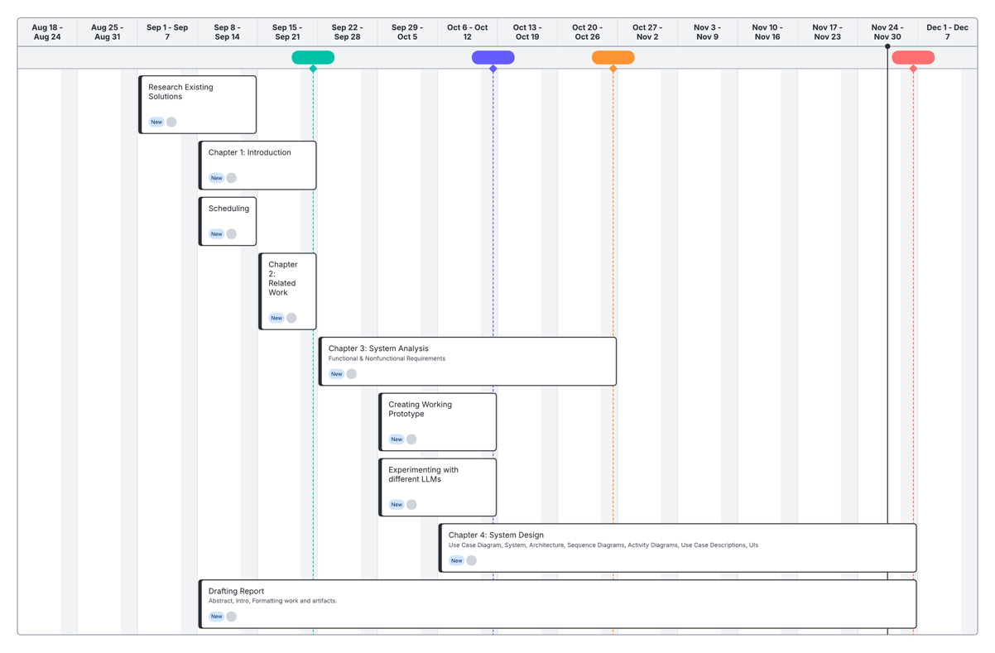
Figure 1: Gantt Chart

1.5.2 Milestones and Deliverables
- Requirements gathering completed.
- Data collection and preprocessing completed.
- System analysis & design completed.
- LLM analyzer prototype completed.
- Documentation and reporting completed.

Chapter 2: Related Work

2.1 Existing Sentiment Analysis Technologies & Solutions
Over the last years, sentiment analysis has moved from simple word lists to machine learning, deep learning, and, more recently, large language models (LLMs). Research on sentiment analysis commonly groups techniques into two main families, lexicon-based and traditional machine-learning, with LLM-based methods now emerging as a third category.

2.1.1 Lexicon-based and Rule-based Methods
Lexicon-based methods rely on predefined lists of positive and negative words (sentiment lexicons). A simple scoring function counts or weights the sentiment-bearing words in a text to decide whether the overall sentiment is positive, negative, or neutral.

Characteristics of Lexicon-based methods
- Use sentiment dictionaries and manually defined rules
- They do not need training data with labels (positive/negative), so they are easy to use when labeled examples are not available

Limitations of Lexicon-based methods
- Sensitive to domain, slang, and informal language (especially social media)
- Struggle with sarcasm, negation (“not good”), and mixed opinions
- Usually produce only a simple polarity result (positive/negative/neutral) and do not naturally provide aspect-level sentiment or detailed emotion categories

2.1.2 Machine-Learning Methods
Machine-learning methods learn from example texts that are already labeled (for example, positive or negative) and then use the learned patterns to predict the sentiment of new texts. This family includes both older models with simple features and newer deep learning models that learn their own text representations. These models usually perform better than lexicon-based methods, but the main drawback is that they need labeled training data for each domain or language.

2.1.3 Large Language Models (LLMs) for Sentiment Analysis
Recent work evaluates large language models as a new class of sentiment-analysis technology. Zhang et al. (2024) conduct a large empirical study where they test several LLMs on 26 different datasets to see how well they perform for sentiment analysis.
Their findings show that LLMs:
- Can perform sentiment-analysis tasks in zero-shot and few-shot settings using prompts, without full supervised training for each dataset
- Achieve competitive performance with smaller, task-specific models on simpler sentiment classification tasks
- Are able, in principle, to output richer structures (e.g., sentiment labels, emotions, and aspects) in a single prompted response
At the same time, Zhang et al. report that:
- LLMs still lag behind well-trained, smaller models on more complex, structured tasks such as full ABSA and some MAST tasks
- LLM performance is sensitive to prompt design and output formatting, especially when the required structure is complex
The literature positions LLM-based techniques as the latest layer in the evolution of sentiment analysis, built on top of lexicon-based, machine-learning-based, and deep learning-based approaches. For our project, this is relevant because we aim to use an LLM to generate multi-dimensional outputs (overall sentiment, emotions, and brand-related aspects).

2.1.4 Existing Solutions

Local Solution – Lucidya
Lucidya is a Saudi-founded, AI-powered customer experience and social listening platform headquartered in Riyadh and focused on organizations in Saudi Arabia. It offers a unified suite that includes social listening, media monitoring, and analytics for marketing, with sentiment analysis specifically optimized for Arabic content. Lucidya reports around 92% sentiment-analysis accuracy for Arabic.

International Solution – Brandwatch
Brandwatch is a widely used social listening and analytics platform that collects data from social networks, forums, blogs, and news sites and applies AI-based sentiment analysis. Its engine classifies conversations by polarity (positive, neutral, negative) and can further label them with basic emotions such as anger, disgust, fear, joy, surprise, and sadness, which are then visualized in interactive dashboards for campaign tracking and crisis detection.

2.2 Technologies Considered

2.2.1 Large Language Models
In the context of brand sentiment analysis, LLMs offer significant advantages over traditional rule-based or classical machine learning approaches. Traditional sentiment analysis tools typically rely on predefined lexicons or simple classification algorithms that struggle with nuanced language, sarcasm, context-dependent meanings. LLMs, by contrast, leverage their extensive pre-training to:
- Understand contextual meanings: LLMs can distinguish between “The battery life is sick!”, which in slang is positive, and “I feel sick of this battery life” which is negative.
- Multi-dimensional analysis: A single LLM can simultaneously extract sentiment scores, identify emotions, and detect aspects being discussed.
- Adaptation to brand-specific language: LLMs can interpret product names and brand terminology without the need for explicit programming.
In our sentiment analysis system, the LLM serves as the core analytical engine. When a social media post enters the system, it is preprocessed (cleaned) and then sent to the LLM with a structured prompt. The prompt instructs the model to return three key outputs:
- Sentiment Score: Numerical value (0-5 scale) indicating sentiment polarity
- Dominant Emotion: The primary emotion expressed (e.g. joy, anger, frustration)
- Aspect: The specific brand element being discussed (e.g. product, price, delivery)

2.2.2 Evaluation Methodology
To assess the capabilities of available LLM technologies for sentiment analysis, we evaluated representative models from both commercial services and open-source alternatives. This evaluation establishes performance expectations and identifies trade-offs between the different approaches. It's worth noting that we evaluated the LLMs by processing the entire dataset at once rather than handling each item individually. While one-by-one processing produces more consistent outcomes, we agreed that batch processing was preferable for this phase of the project because it introduces greater variance in the results, making our assessment more straightforward.

Test Dataset
We constructed a control dataset of 50 social media posts about a major technology product (iPhone 17). Each post was manually annotated for sentiment score (0-5 scale), dominant emotion, and aspect being discussed. A smaller subset of 10 posts from this dataset was made to test local LLMs, because of issues with local LLMs due to hardware limitations.

Evaluation Metrics
Mean Absolute Error (MAE) measures the average magnitude of prediction errors:
$$MAE=\frac{1}{n}\sum{\left|predicted-actual\right|}$$
MAE provides an intuitive understanding of typical accuracy. For example, MAE of 0.35 indicates predictions deviate from ground truth by an average of 0.35 points on the 0-5 sentiment scale. Lower values indicate better performance.
Root Mean Square Error (RMSE) essentially provides similar insights to MAE, but penalizes larger errors more heavily:
$$RMSE=\sqrt{\frac{1}{n}\sum{{\left(predicted-actual\right)}^{2}}}$$
By squaring errors before averaging, RMSE disproportionately penalizes catastrophic misclassifications. This is particularly important for brand monitoring, where missing a viral negative post has greater consequences than minor scoring imprecision across many routine posts.

Testing Procedure
All models were evaluated under identical conditions:
- Identical generic prompt
- No pre-training, nor fine-tuning
- Each model processed the whole batch at once

Prompt Message
You are an expert sentiment analyzer, and your job is to take a CSV file that has posts about the topic of iPhone 17, and provide the following for each post:
* Sentiment Score from 0.0 (very negative) to 5.0 (very positive), where between 2 and 3 is neutral.
* The dominant emotion that lays within the text. (e.g. happy, sad, angry, neutral, optimistic, etc.)
* The aspect of which the post focused on (e.g. product, service, quality, delivery, price, etc.)

Examples:
1. "The new iPhone 17 color is so freaking ugly, whoever thought of orange as a phone's color should be immediately fired.":
1. Score: 0.2
2. Emotion: Angry
3. Aspect: Product

2. "Although the new iPhone 17 is expensive, it provides a lot of useful features that are exclusive to the iPhone.":
1. Score: 2.4
2. Emotion: Neutral
3. Aspect: Price

3. "I just got my iPhone delivered this evening when I just ordered this morning! Bravo, Apple!":
1. Score: 4.8
2. Emotion: Happy
3. Aspect: Delivery

Respond only in CSV format that contains the post text, score, emotion and aspect as columns.
Preserve the same order of the original file, and make sure you've analyzed exactly 50 posts.

2.2.3 Production-Level LLMs
We evaluated 5 commercially available LLMs:
- Perplexity
- Grok 4.1
- GPT 5.1
- Deepseek-R1
- Gemini 3 Pro

Performance Results
Model | Sentiment MAE | Sentiment RMSE | Sentiment Average
Control | - | - | 2.86
Perplexity | 0.554 | 0.446 | 3.182
Grok 4.1 | 0.562 | 0.661 | 3.262
GPT 5.1 | 0.804 | 0.986 | 2.76
Deepseek-R1 | 0.520 | 0.645 | 3.36
Gemini 3 Pro | 0.318 | 0.445 | 2.91
Table 1: Production LLMs Sentiment Analysis Performance
The table reveals that Gemini 3 Pro achieved the best performance with the lowest MAE of 0.318 and RMSE of 0.445 when tested against the control dataset. Perplexity and GPT 5.1 also demonstrated promising results, which suggests that further refinement of their prompts could yield more consistent and reliable outcomes.

2.2.4 Open Source LLMs for English
We evaluated several open-source LLM alternatives:
- Llama 3.2 3B Instruct - Meta's multilingual model optimized for dialogue use cases, including agentic retrieval and summarization tasks. Officially supports multiple languages. Features 128K context length support.
- Qwen 3-VL 4B - Alibaba's vision-language model from the Qwen series, designed to process both text and images with strong reasoning capabilities across multiple languages.
- Jais 7B - Developed by Inception and Cerebras Systems, this model is part of the Jais family of bilingual English-Arabic large language models. Jais-adapted models are pre-trained adaptively from Llama-2 and optimized to excel in Arabic (MSA) while maintaining strong English capabilities.
- ALLaM 7B Instruct - Developed by the National Center for Artificial Intelligence (NCAI) at the Saudi Data and AI Authority (SDAIA), ALLaM is a series of powerful language models designed to advance Arabic Language Technology.

Performance Results
Model | Sentiment MAE | Sentiment RMSE | Sentiment Average
Control | - | - | 3.28
Llama 3.2 | 0.800 | 1.158 | 3.28
Qwen 3-VL | 0.420 | 0.694 | 3.20
Jais | 1.060 | 1.391 | 4.04
ALLaM | 0.540 | 0.656 | 3.32
Table 2: Open-Source LLMs Sentiment Analysis Performance
Due to the batch-processing approach and a reduced sample size compared to what was provided to production-level LLMs, this table displays somewhat greater deviation from the control dataset than Table 1, with notably higher variance across each metric. No definitive leader emerges, highlighting the challenges associated with open-source LLMs.

2.2.5 Open Source LLMs for Arabic
We conducted exploratory testing to assess the feasibility of future Arabic language support. This investigation was motivated by the unique technical challenges Arabic presents: dialectical variations, and the prevalence of informal social media language that differs substantially from Modern Standard Arabic (MSA). (MSA is the formal, standardized form of Arabic, evolving from Classical Arabic).
Understanding Arabic sentiment analysis capabilities would inform future roadmap decisions and help estimate the effort required to expand the system's linguistic coverage. This exploratory phase focused on establishing baseline performance metrics and identifying which model architectures show promise for Arabic text analysis.

Test Dataset
We constructed a control dataset of 10 Arabic social media posts about Almarai dairy company. Each post was manually annotated for sentiment score (0-5 scale), dominant emotion, and aspect being discussed. The posts were in Saudi dialect, and were found on X.

Performance Results
We evaluated the same open source models in subsection 2.2.4:
Model | Sentiment MAE | Sentiment RMSE | Sentiment Average
Control | - | - | 3.81
Llama 3.2 | 1.54 | 1.708 | 3.07
Qwen 3-VL | 1.23 | 1.650 | 3.28
Jais | 0.61 | 0.753 | 3.48
ALLaM | 0.89 | 1.182 | 3.88
Table 3: Open Source LLMs Arabic Sentiment Analysis Performance
The table reveals that Jais achieved the best performance with the lowest MAE of 0.61 and RMSE of 0.753 when tested against the control dataset. ALLaM also demonstrated promising results with an MAE of 0.89, which suggests that Arabic-specialized models significantly outperform general multilingual alternatives. These results indicate that Arabic sentiment analysis – while technically feasible – still lacks behind English sentiment analysis.

2.2.6 Social Media APIs
Data collection from social media platforms presented significant technical and practical challenges. The ability to gather relevant posts at scale directly impacts the system’s effectiveness.

Web Scraping Tools
Initial exploration focused on web scraping tools as a cost-effective alternative to official APIs. Several Python-based scraping libraries were evaluated, including snscrape, which had been widely used for collecting social media data from platforms like X (formerly Twitter). However, recent policy changes on X have rendered traditional scraping approaches useless.
X implemented stricter anti-scraping measures and rate limiting in 2023–2024, requiring authentication for even basic content access. These changes broke compatibility with most third-party scraping tools. Specifically, snscrape—which had previously enabled unauthenticated data collection—ceased functioning after X’s platform updates. Attempts to work around these restrictions proved unsuccessful, as X continuously updates its defenses against automated data collection.

Official X API
The official X API represents the authorized method for accessing platform data, but pricing presents a significant barrier for academic and small-scale projects. The current API tier structure includes:
- Free Tier: 100 posts/month
- Basic Tier: 10,000 posts/month for $200/month
For a sentiment analysis system requiring hundreds or thousands of posts to generate statistically meaningful insights, the free tier’s 100-post monthly limit is insufficient. A single brand analysis session could easily exceed this quota.

Reddit API (PRAW)
Given the limitations with X, the project moved to Reddit as the primary data source using the Python Reddit API Wrapper (PRAW). PRAW offers free access with much more generous rate limits than X API.

Chapter 3: System Analysis

3.1 Development Methodology
In software engineering theory, process models are often presented as either plan-driven (such as the waterfall model) or agile. Plan-driven approaches assume that requirements, design, and plans can be defined in detail early and then followed step by step, while agile approaches organize the work into short iterations that deliver working software and expect requirements to change over time. Sommerville notes that real projects rarely follow a pure form of either model; instead, industry tends to mix agile and plan-based practices and combine the strengths of both. We will follow this view: we use some upfront planning and documentation, but our methodology is clearly biased towards an agile, iteration-based way of working.
This agile orientation fits our system and constraints. The project depends on external social-media data sources and LLMs whose behavior we cannot fully fix at the start. On the data side, platforms such as X have tightened access, rate limits, and pricing, which forced us to move from scraping tools to the Reddit API (PRAW) as a more realistic source. On the model side, our evaluation shows that different LLMs (commercial and open source) offer different trade-offs in accuracy, Arabic support, context handling, and cost, and many state-of-the-art models are either too expensive or too heavy for our available hardware. These factors mean that both data sources and model choices must be adjusted over time based on experiments rather than decided once. An agile process that uses sprints, a prioritized backlog, and regular re-planning allows us to respond to these changes instead of treating them as exceptions.

3.2 Positional Users

3.2.1 Marketing Team User
Role: Interacts directly with the system to generate sentiment analysis reports and interpret customer feedback insights.
Responsibilities:
- Initiates brand sentiment analysis by selecting sources or uploading datasets
- Reviews sentiment results, emotional distributions, aspect-based insights, and summary indicators
- Provides feedback on accuracy of analysis
- Uses insights to support decision-making and marketing strategies

3.2.2 System Administrator
Role: Manages user accounts, system configurations, and views analytical data.
Responsibilities:
- Creates and approves user accounts
- Manages system permissions and user access levels
- Monitors system status and ensures smooth operation

3.3 Functional Requirements

Data Handling
- The system shall collect posts from a social media platform.
- The system shall allow uploading of custom datasets in CSV format.
- The system shall detect language (Arabic/English) and preprocess text for analysis.

Sentiment & Aspect Analysis
- The system shall assign a score to represent sentiment (negative, neutral, positive).
- The system shall provide a confidence score for each classification.
- The system shall detect main aspects such as product, service, delivery, and pricing.
- The system shall detect basic emotions including joy, anger, and sadness.

Dashboard & Reporting
- The system shall provide a dashboard showing sentiment trends, aspect analysis, and emotion distribution.
- The system shall allow filtering by date, sentiment type, aspect, and language.
- The system shall allow exporting reports in CSV format.

User Roles & Feedback
- The system shall support role-based access (Admin, Marketing Team).
- The system shall allow users to provide feedback on misclassified posts for model improvement.

3.4 Non-Functional Requirements

Performance
- The system shall return dashboard results within 2 seconds for standard queries.

Usability
- The system shall provide a dashboard that enables non-technical users to access key sentiment metrics within 3 clicks from the home screen.
- The system shall support responsive design for desktop and mobile access.

Accuracy & Quality
- The system shall maintain consistent sentiment analysis accuracy (within 5% variance) for analyzed posts

Security
- The system shall enforce secure authentication and role-based access control

Reliability & Availability
- The system shall handle errors gracefully and provide clear error messages

Maintainability & Scalability
- The system architecture shall separate the LLM analyzer, data processing, and presentation layers through well-defined APIs
- The system shall support scaling to additional data sources in future phases

3.5 Use Case Model

3.5.1 Use Case Diagram
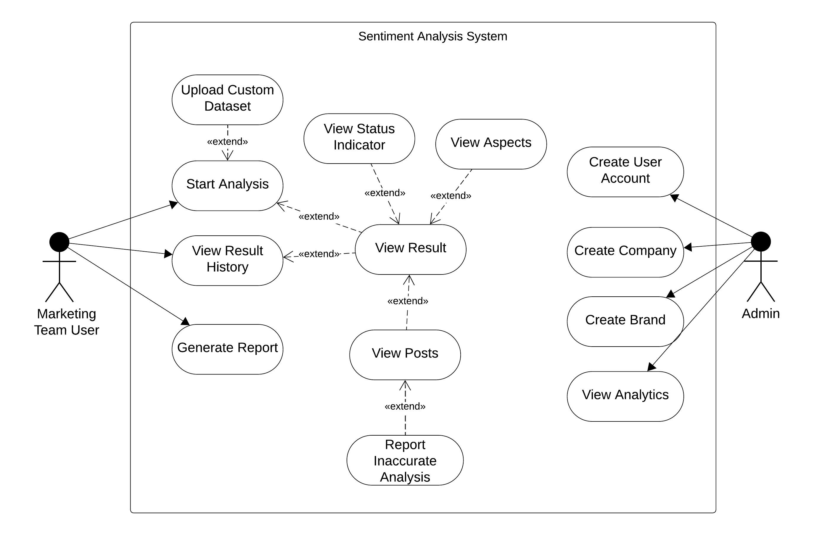
Figure 2: Use Case Diagram
The system supports two main actor roles: Marketing Team Users, who perform sentiment analysis and review results, and Admins, who manage user accounts and monitor system analytics.
Marketing Team Users can initiate sentiment analysis through two pathways: collecting data directly from social media platforms via Start Analysis or uploading custom datasets through Upload Custom Dataset. Once analysis is complete, users access comprehensive results through View Result, which serves as the central hub for detailed examination. From this hub, users can navigate to detailed views including View Aspects, View Status Indicator, and View Posts. Additionally, users can view historical reports through View Result History, exporting data via Generate Report, and reporting misclassifications through Report Inaccurate Review, which extends from View Posts.
Admin users have access to system management functions including Create User Account for managing system access, View Analytics for monitoring overall system usage and LLM performance across the platform, and View Reported Reviews to examine misclassifications.

3.5.2 Use Case Descriptions
Use Case Name | Start Analysis
Scenario | Marketing team user starts an analysis
Triggering Event | Marketing team user click the “Start Analysis” button on the dashboard
Brief Description | This use case allows marketing team employees to initiate automated sentiment analysis on social media posts related to their brand. The system collects posts from specified sources, analyzes them using LLM-based processing to extract sentiment, emotions, and aspects, then aggregates the results into a comprehensive brand status report.
Actors | Marketing Team User
Related Use Cases (if any) | None
Preconditions | - System must have connectivity to social media API  - LLM Analyzer service must be operational
Postconditions | - Analysis report is generated and stored in the database  - Dashboard displays “Analysis Complete” status message  - “View Results” button is enabled to the user
Flow of Activities | Marketing Team User | System
 | - Clicks “Start Analysis” button  - Fills in config form  - Submits analysis request  - Wait for analysis to complete  - View “Analysis Complete” message  - Clicks “View Results” to access report | - Displays analysis config form to user  2.1 Validate input parameters  3.1 Retrieve brand details and keywords  3.2 Display “Analysis Started” message  4.1 Collect posts from social media  4.2 Send posts to LLM analyzer  4.3 Receive results and generate report  5.1 Display “Analysis Complete” message  6.1 Retrieve and display complete report
Exception Conditions | E2.1 Invalid Input  E4.1 Social media API failure  E4.2 LLM analyzer unavailable
Table 4: Start Analysis Use Case Description

Use Case Name | View Result
Scenario | Marketing Team User views the results of a sentiment analysis report (either newly generated or previously saved)
Triggering Event | User clicks on a completed report from View Report History or dashboard
Brief Description | This use case allows the Marketing Team User to view an overview and summary of a completed sentiment analysis report. The overview displays aggregated sentiment scores, emotion distribution, aspect breakdown, and overall confidence levels for a brand's analyzed social media posts. From this view, users can navigate to more detailed views of aspects, status indicators, and individual posts.
Actors | Marketing Team User
Related Use Cases (if any) | View Aspects, View Status Indicator, View Posts, View Report History, Generate Report
Preconditions | - The Marketing Team User is authenticated and logged in.  - At least one analysis report must exist for the selected brand  - The report status must be "finished" (not "processing" or "error")
Postconditions | - User successfully views the analysis report overview and summary  - User can navigate to related detailed views (View Aspects, View Status Indicator, View Posts)
Flow of Activities | Marketing Team User | System
 | - Clicks on a completed report from the report list or dashboard  - Reviews displayed report summary  - Optionally navigates to View Aspects, View Status Indicator, or View Posts for detailed analysis  - Optionally, clicks on Generate Report | - Retrieves report data from the database  - Displays the report overview  - Handled by Generate Report use case
Exception Conditions | E2 No Analytics Available  E3 Analysis Failed  E4 Analysis Still Processing
Table 5: View Result Use Case Description

Use Case Name | View Posts
Scenario | Marketing Team User views individual analyzed posts from a sentiment analysis report
Triggering Event | User clicks on the posts card/section within the View Result dashboard
Brief Description | This use case allows the Marketing Team User to view detailed information about individual social media posts that were analyzed in a report. Posts are displayed in a paginated table format showing post text, sentiment score, dominant emotion, detected aspect, and confidence level. Users can filter and sort posts by various criteria including sentiment range, emotion type, aspect type, confidence level, and date range.
Actors | Marketing Team User
Related Use Cases (if any) | View Result, Report Inaccurate Analysis
Preconditions | - The Marketing Team User has accessed View Result page  - Post analysis is complete with sentiment scores, emotions, aspects, and confidence
Postconditions | - User successfully views the list of analyzed posts  - User can filter and sort posts by multiple criteria  - User returns to the View Result dashboard  - User can report inaccurate analysis for individual posts
Flow of Activities | Marketing Team User | System
 | - Clicks on the posts card  - Reviews displayed posts  - Optionally apply filters and sorting  - Optionally report inaccurate analysis | - Retrieves post & analysis data from database  - Displays posts in paginated table format: Post text, Sentiment score, Dominant emotion. Detected aspect. Confidence level.  - Updates view to reflect filters and sorting  - Handled by Report Inaccurate Analysis
Exception Conditions | E2 Database Connection Failure  E5 No Posts Match Filter Criteria
Table 6: View Posts Use Case Description

Use Case Name | View Aspects
Scenario | Team User views the aspect breakdown of a sentiment analysis report
Triggering Event | User clicks on the aspects card/section within the View Result dashboard
Brief Description | This use case allows the Marketing Team User to view a detailed breakdown of aspects detected in analyzed social media posts. The aspects view displays aspect types ranked by frequency (number of posts mentioning each aspect), along with corresponding sentiment scores, emotion distribution per aspect, and post counts. This enables marketing teams to identify which specific areas (product, service, pricing, delivery, customer service, etc.) are driving customer sentiment and where attention is needed.
Actors | Marketing Team User
Related Use Cases (if any) | View Result
Preconditions | - The Marketing Team User has accessed View Result page  - The report contains complete analyzed posts with aspects
Postconditions | - User successfully views the aspect analysis breakdown  - User can filter aspects by aspect type  - User returns to the View Result overview
Flow of Activities | Marketing Team User | System
 | - Clicks on the aspects card  - Reviews the displayed aspect analysis and statistics  - Returns to View Result overview | - Retrieves aspect data from database  - Displays the aspect analysis data:  - Aspect name  - Posts included in each aspect  - Average score per aspect  - Emotion distribution
Exception Conditions | E1 No Aspects Detected in Analysis  E2 Database Connection Failure
Table 7: View Aspects Use Case Description

Use Case Name | View Status Indicator
Scenario | Marketing Team User views the overall brand status indicator
Triggering Event | User clicks on the status indicator card/section within the View Result dashboard
Brief Description | This use case allows the Marketing Team User to view the aggregated brand status indicator, which provides a comprehensive overview of the overall sentiment health. The status indicator displays a color-coded sentiment score, emotion analytics including the dominant emotion and top emotions breakdown, confidence metrics, emotion diversity, and an LLM-generated interpretive comment summarizing the analysis findings.
Actors | Marketing Team User
Related Use Cases (if any) | View Result
Preconditions | - The Marketing Team User has accessed View Result page  - Aggregated calculations for the report are complete  - The report contains analyzed posts
Postconditions | - User successfully views the brand status indicator metrics  - User returns to the View Result overview
Flow of Activities | Marketing Team User | System
 | - Clicks on the status indicator card  - Reviews the displayed status metrics and insights  - Returns to View Result overview | - Retrieves report score data from database  - Displays the status indicator data:  - Color-coded status  - Sentiment breakdown  - Dominant emotion  - Top 3 emotions  - Diversity score  - Confidence level  - Summary
Exception Conditions | E2 Database Connection Failure
Table 8: View Status Indicator Use Case Description

Use Case Name | Report Inaccurate Review
Scenario | After viewing the analyzed posts inside the View Posts use case, the user may notice that a specific post’s sentiment, emotion, or aspect classification is incorrect. The user clicks the “Inaccurate Analysis” button and submits a brief explanation. The system records this feedback for model improvement.
Triggering Event | The user clicks “Inaccurate Analysis” after viewing analyzed posts.
Brief Description | This use case allows the marketing team user to report that the system misinterpreted a specific post. When triggered, the system displays a small feedback input box. The user types a brief description and submits it. The feedback entry is stored in the system and linked to the corresponding analysis record for future review and model refinement.
Actors | Marketing Team User
Related Use Cases (if any) | View Posts
Preconditions | - The user is logged in.  - The user is currently inside the View Posts use case.  - The analysis has been completed and posts are available to review.
Postconditions | - The feedback entry is saved in the system.  - The feedback is linked to the correct userId, analysisId, and post.  - A confirmation message is returned to the user.
Flow of Activities | - Actor’s Actions  The user clicks “Inaccurate Analysis” after viewing a post.  The user enters a brief explanation of the issue.  The user clicks “Send Feedback.”  - System’s Responses  The system displays a feedback text field.  The system receives the feedback input.  The system saves the feedback (userId, analysisId, brief) through the feedback service and repository, then returns a success message.
Exception Conditions | - User submits empty feedback. System displays: “Please enter a brief explanation.”  - Feedback storage fails. system displays an error: “Could not submit feedback. Try again later.”
Table 9: Report Inaccurate Review Use Case Description

Use Case Name | View Analytics
Scenario | The Admin accesses the analytics dashboard to monitor system usage and brand analysis activity across the system.
Triggering Event | The Admin navigates to the "View Analytics" page from the admin dashboard.
Brief Description | This use case allows the Admin to view comprehensive analytics about system usage and brand analysis activity. The analytics provide insights into LLM utilization, post analysis trends, brand performance metrics, and other key indicators. The Admin can apply various filters to refine the view and focus on specific time periods, companies, brands, or other criteria.
Actors | Admin
Related Use Cases (if any) | None
Preconditions | - The Admin is authenticated and logged into the system.
Postconditions | - The system displays the latest analytical results retrieved from the database.  - The analytics dashboard remains accessible for further exploration and filtering.
Flow of Activities | Admin | System
 | - Navigates to "View Analytics"  - Reviews displayed analytics  - Optionally, applies filter criteria (date range, brands, etc.)  - Reviews filtered analytics | - Retrieves all analytics from the database  - Populates analytics dashboard  - Applies filter function on the data  - Displays criteria-met data
Exception Conditions | E2 No Analytics Available  E2 Database Connection Failure  E5 Invalid Filter Criteria
Table 10: View Analytics Use Case Description

Use Case Name | Upload Custom Dataset
Scenario | After starting a new analysis, the marketing team user may choose to upload a custom dataset instead of using the system’s default data source. This dataset is then used as the input for sentiment analysis.
Triggering Event | The user selects “Start Analysis”, and within the configuration options, clicks “Upload Custom Dataset”.
Brief Description | his use case allows the marketing team user to upload a CSV or XLSX file containing posts, comments, or text data to be analyzed. The system validates the file type and size, uploads it, stores it, and makes it available for processing. The custom dataset replaces the standard social media data source for the analysis run.
Actors | Marketing Team User
Related Use Cases (if any) | Start Analysis
Preconditions | - The user is logged in and authorized.  - The user has already initiated the Start Analysis use case.  - The file is available on the user’s device.
Postconditions | - The uploaded dataset is stored in the system.  - The dataset is linked to the analysis request.  - The system is ready to run sentiment analysis using the custom uploaded data.
Flow of Activities | Actor’s Actions:  - The user starts a new analysis.  - The user selects “Upload Custom Dataset”.  - The user chooses a CSV/XLSX file and submits it.  System’s Responses:  - The system displays analysis options, including dataset upload.  - The system opens a file upload window or prompt.  - The system validates the file type and size, uploads it, stores it, and confirms successful upload.
Exception Conditions | - Invalid file format. System displays: “Unsupported file type. Please upload CSV or XLSX.”  - File too large. System displays: “File exceeds size limit.”
Table 11: Upload Custom Dataset Use Case Description
Use Case Name | Generate Report
Scenario | Marketing Team User generates a downloadable sentiment analysis report containing posts and their analysis results in CSV format.
Triggering Event | Marketing Team User clicks the "Generate Report" button in the dashboard interface.
Brief Description | This use case enables Marketing Team Users to generate comprehensive reports containing sentiment analysis results for social media posts. The system retrieves analyzed posts from the database, including sentiment scores, aspect analysis, and emotion detection, then compiles them into a structured CSV file format. The generated report provides a downloadable file that can be used for offline analysis, presentations to stakeholders, or integration with other business intelligence tools.
Actors | Marketing Team User
Related Use Cases (if any) | View Result
Preconditions | - At least one analysis must have been completed  - The database must contain post data with analysis report
Postconditions | - CSV file containing posts and their sentiment analysis is exported successfully  - Download URL for the CSV file is created and returned to the user
Flow of Activities | Marketing Team User | System
 | - Clicks “Generate Report” button  - Receive download URL | - Fetches posts and reviews from database  - Creates and formats a CSV file with report data  - Create a download URL  - Return URL to user
Exception Conditions | E1 Invalid Report ID  E2 Database Connection Failure  E3 Empty Dataset  E4 CSV Service Failure  E5 Insufficient Permissions
Table 12: Generate Report Use Case Description

3.6 Prototyping & Feasibility Testing
To validate the feasibility of the proposed system, a functional prototype was developed and tested. The prototype implements a complete end-to-end pipeline that collects posts from Reddit, performs data cleaning and preprocessing, and analyzes posts individually using a prompted Llama 3.2-3B model.
Despite the model's relatively small size of 3 billion parameters, the prototype demonstrates promising results in sentiment classification, emotion detection, and aspect extraction.
The complete prototype implementation, including source code, analysis results, and documentation, is publicly available at a GitHub repository here.
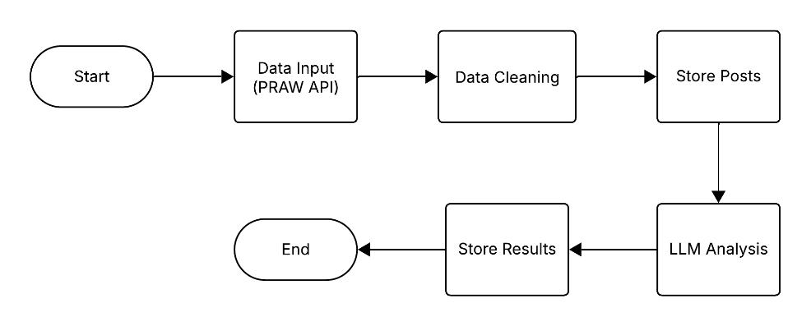
Figure 3: Prototype Flowchart

Text | Score | Emotion | Aspect | Confidence
Its very salty. I couldn’t enjoy it | -2 | sad | product | 0.8
The fries!! Nothing like fresh fries from McDonlad’s. | 3.0 | happy | product | 0.8
People still eat at McDonald’s…? | -3.732 | angry | product | 1.0
Table 13: Prototype Sample Result on McDonald's Using (-4, 4) Scoring

Chapter 4: System Design

4.1 System Architecture
The system consists of a Frontend, Backend Application, Database, Job Queue, LLM service, and Post provider API (e.g. Reddit). These components communicate through REST APIs. Backend retrieves posts from the post provider API, stores data in the database, and manages processing tasks (e.g. Request analysis) through an internal job queue. The LLM service reads jobs from this queue and processes them.
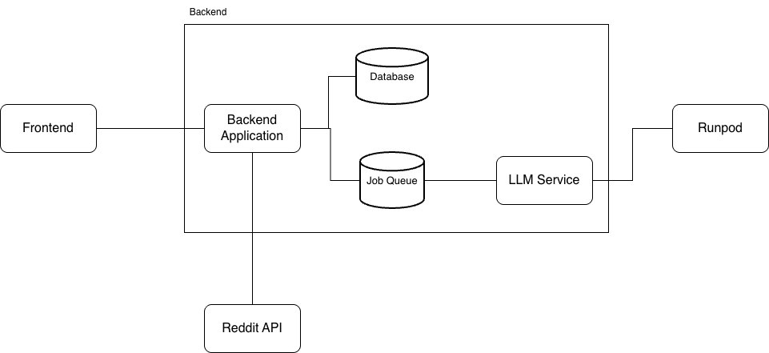
Figure 4: System Architecture Diagram

4.2 System Design

4.2.1 Domain Class Diagram
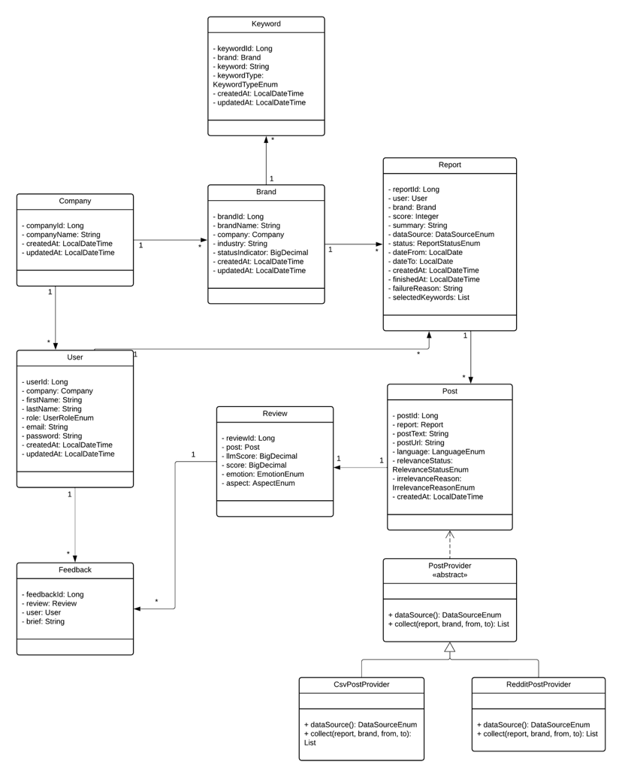
Figure 5: Class Diagram

4.2.2 Sequence Diagrams
This subsection presents the key workflows of the sentiment analysis system through detailed sequence diagrams. Each diagram illustrates the interactions between system components, from user interface to controllers, services, and data repositories, showing how data flows through the system to deliver actionable insights. These workflows cover both user initiated actions and automated processes that power the system's sentiment analysis.
Sentiment Analysis Workflow
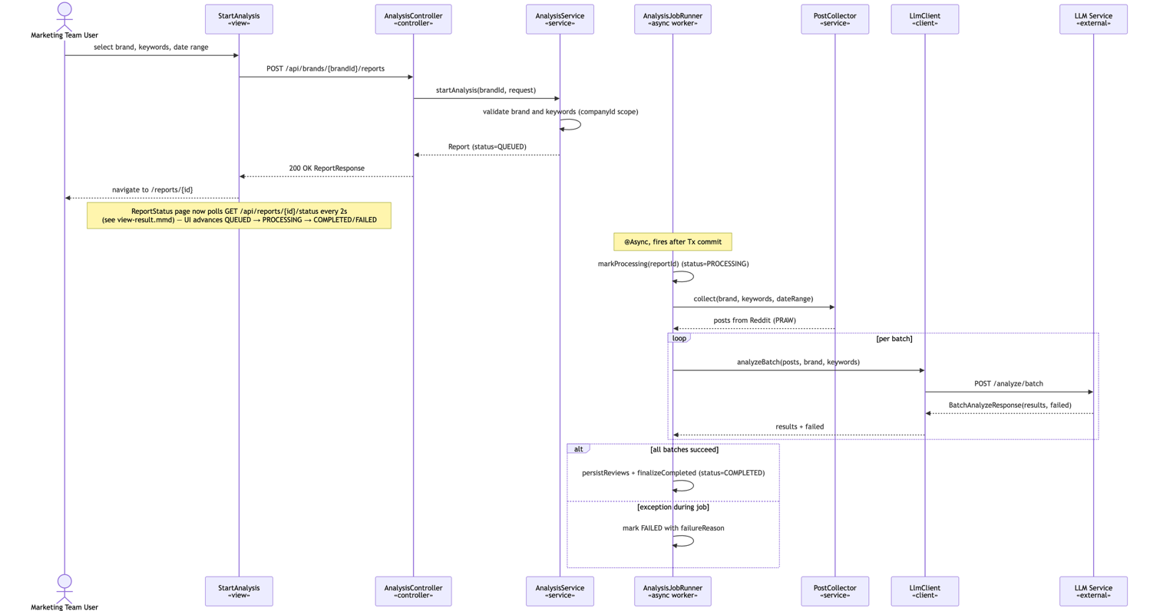
Figure 6: Start Analysis Sequence Diagram
The Sentiment Analysis workflow demonstrates how the system processes social media data. After the user submits analysis parameters, the system validates inputs, retrieves relevant posts from social media platforms, and processes them through the LLM analyzer to extract sentiment scores, emotions, and aspects.

Uploading a Custom Dataset Workflow
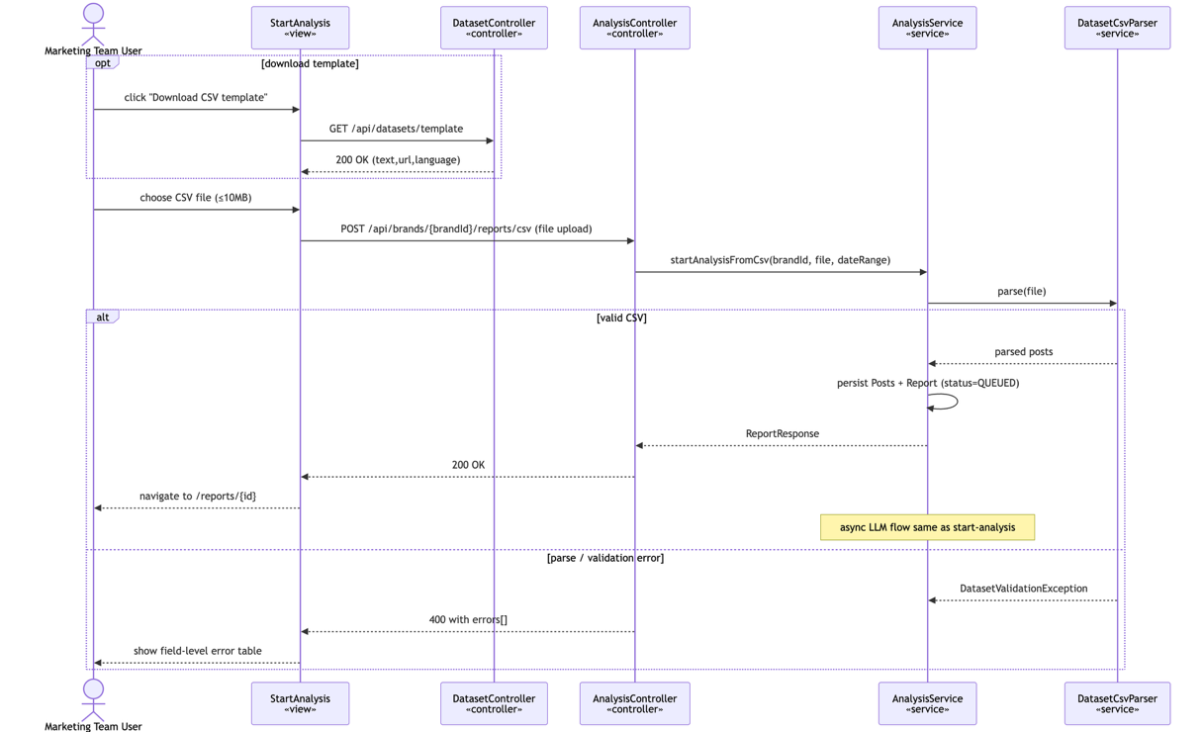
Figure 7: Upload Custom Dataset Sequence Diagram
The Upload Custom Dataset workflow provides flexibility for teams to analyze historical data or proprietary sources beyond social media feeds. The system validates uploaded files (CSV/XLSX format), checks file integrity and structure, then stores the dataset for processing.
Generating Report Workflow
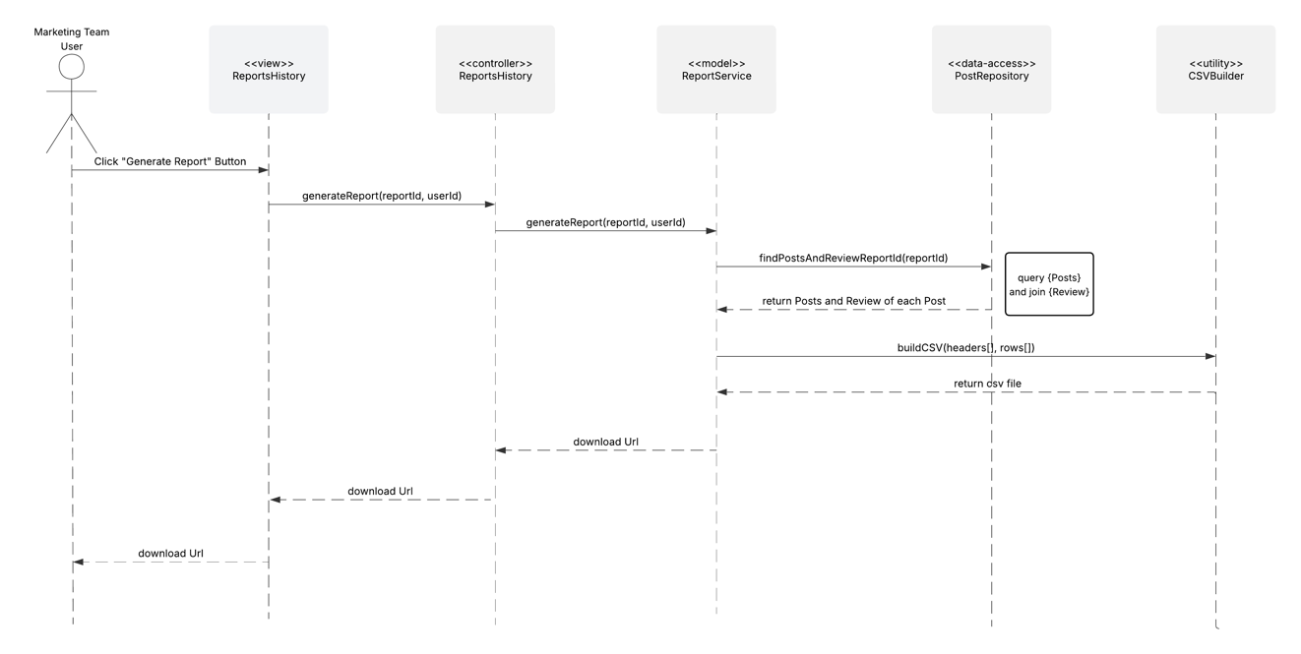
Figure 8: Generate Report Sequence Diagram
The Generate Report workflow transforms analyzed sentiment data into exportable, presentation-ready reports. The system aggregates post-level sentiment scores and analysis results, builds visualizations showing trends and distributions, and compiles everything into a downloadable CSV file.

Viewing Previous Reports Workflow
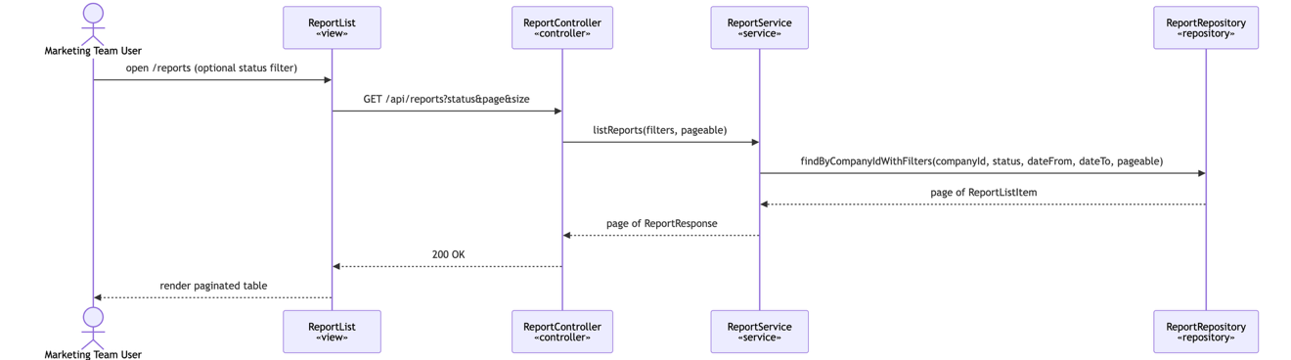
Figure 9: View Result History Sequence Diagram
The View Report History workflow enables users to access and review past analysis reports. Users can filter reports by brand, date range, or other criteria, and the system retrieves matching reports from the database.

Viewing Result Report of an Analysis Workflow
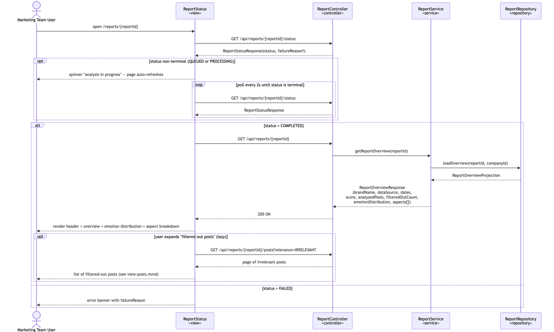
Figure 10: View Result Sequence Diagram
The View Result workflow enables users to access completed sentiment analysis reports. When a user clicks on a report, the system validates the report ID, retrieves report and analysis data from the database, calculates aggregate scores, and displays a comprehensive overview including sentiment scores, emotion distribution, aspect breakdown, confidence levels, and summary statistics. Users can optionally navigate to detailed views (Aspects, Status Indicator, Posts) or generate a new report. Optional navigations are discussed next.
Viewing Analyzed Posts Workflow
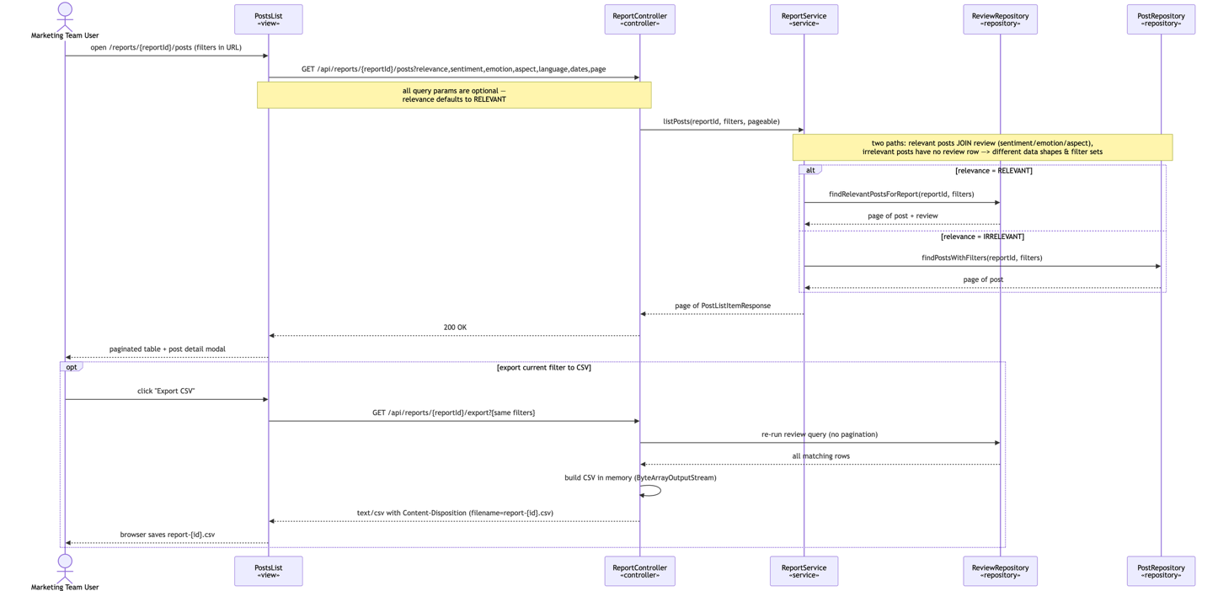
Figure 11: View Posts Sequence Diagram
The View Posts workflow allows marketing team users to examine individual analyzed posts in detail. After clicking to view analyzed posts from a report, the system retrieves both the post data and associated analysis results from the database.
Viewing Status Indicator of an Analysis Workflow
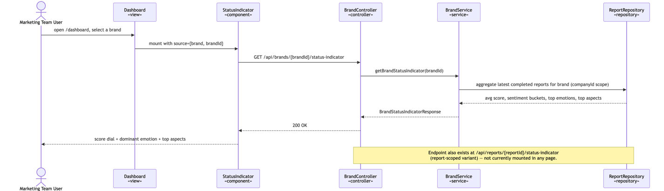
Figure 12: View Status Indicator Sequence Diagram
The View Status Indicator workflow provides an aggregated overview of brand sentiment health. When the user clicks on the status indicator card, the system validates the report ID, retrieves all associated analysis data, and calculates key metrics: aggregate sentiment score, emotion distribution, dominant emotion, top 3 emotions, and confidence level. The dashboard then displays these computed metrics.

Viewing Aspects of an Analysis Workflow
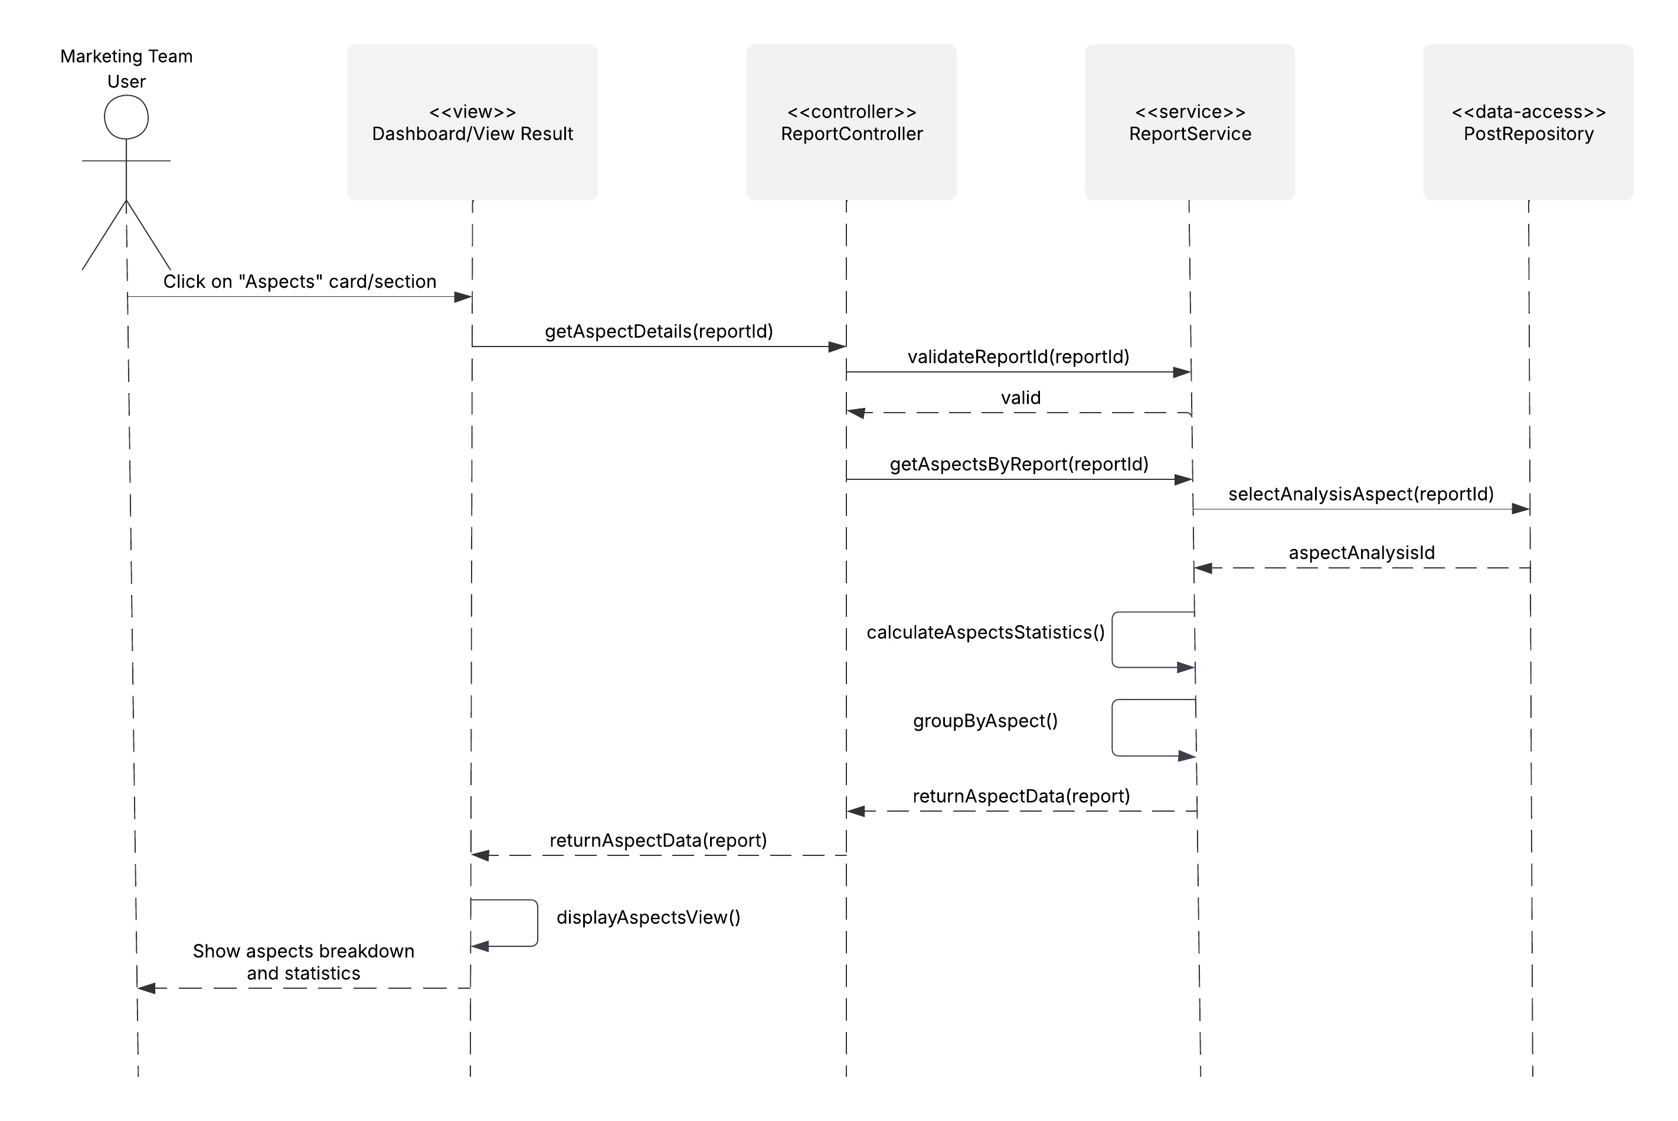
Figure 13: View Aspects Sequence Diagram
When the user clicks on the aspects card, the system validates the report ID, retrieves aspect analysis data, groups posts by aspect type, and calculates statistics (sentiment scores, emotion distribution, post counts) for each aspect.
Reporting an Inaccurate Review Workflow
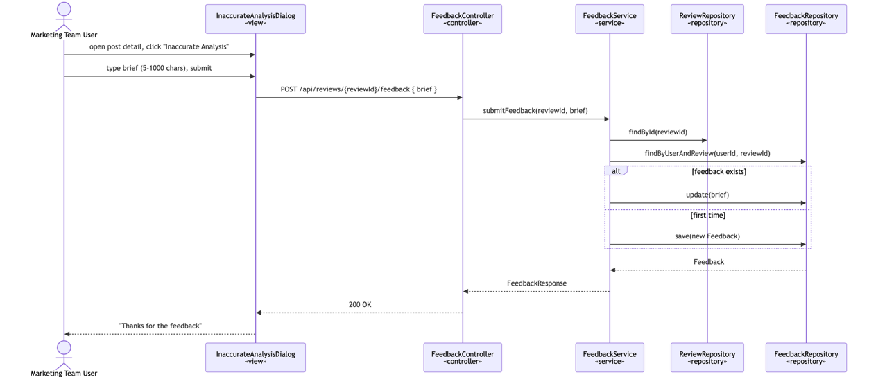
Figure 14: Report Inaccurate Review Sequence Diagram
When a user identifies incorrect sentiment analysis on a post, they click "inaccurate analysis," enter a feedback brief explaining the issue, and submit. The system records the feedback (userId, analysisId, brief) in the feedbackRepository for future model improvement and returns confirmation to the user.

4.2.3 Activity Diagrams
This subsection presents two workflows that represent the system's core data ingestion mechanisms: Start Analysis and Upload Custom Dataset. These workflows were selected because they represent the two primary entry points for data into the system, one handling social media data collection and analysis, and the other enabling users to analyze manually – or by other means – collected datasets.
Sentiment Analysis Workflow
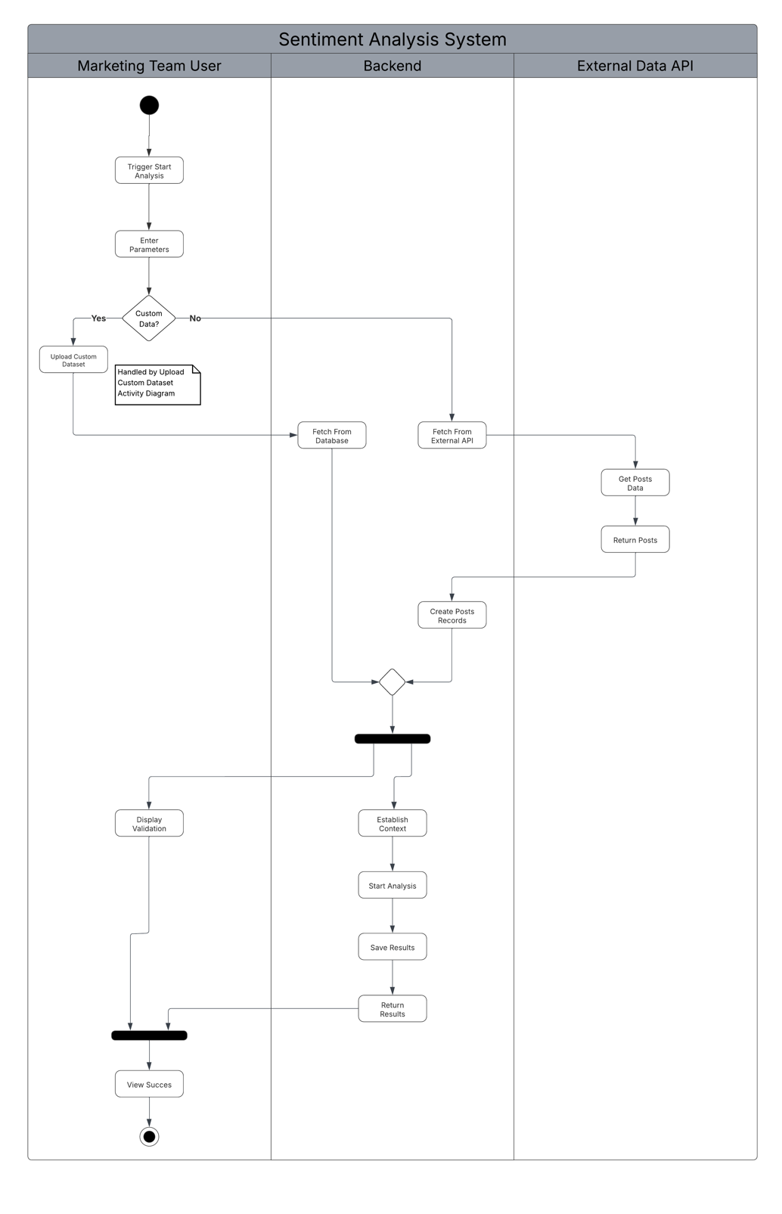
Figure 15: Start Analysis Activity Diagram

Uploading a Custom Dataset Workflow
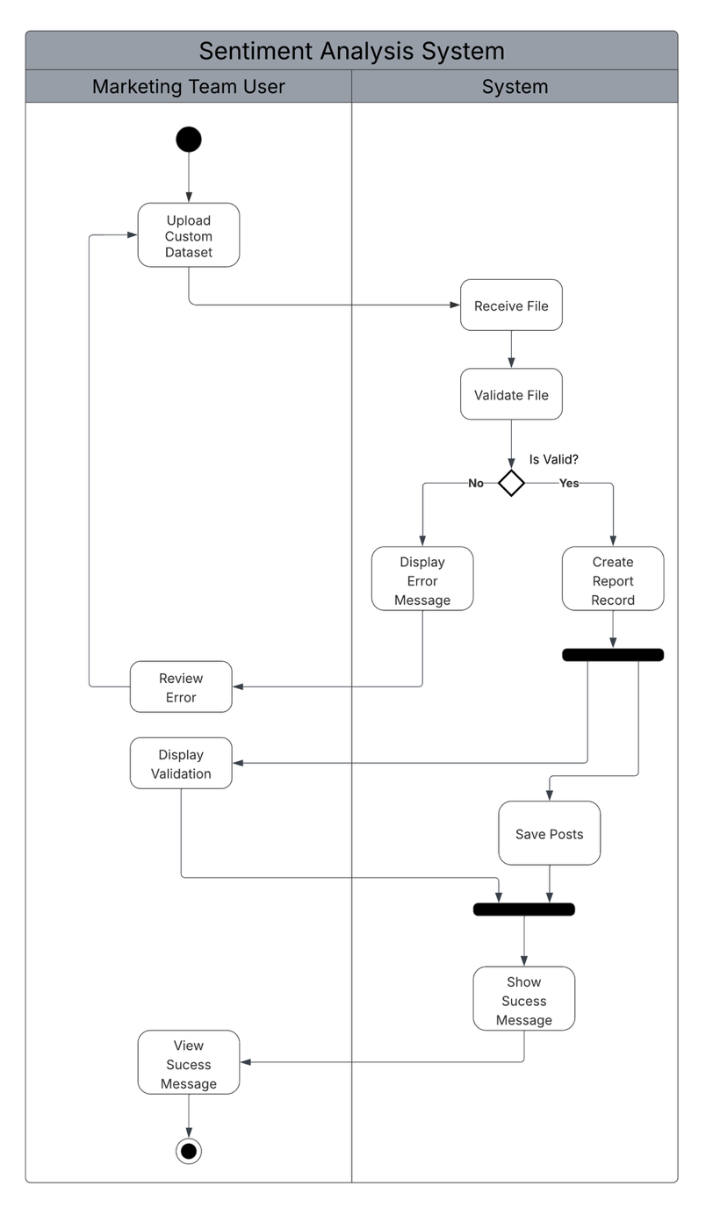
Figure 16: Upload Custom Dataset Activity Diagram

4.2.4 Entity-Relationship Diagram
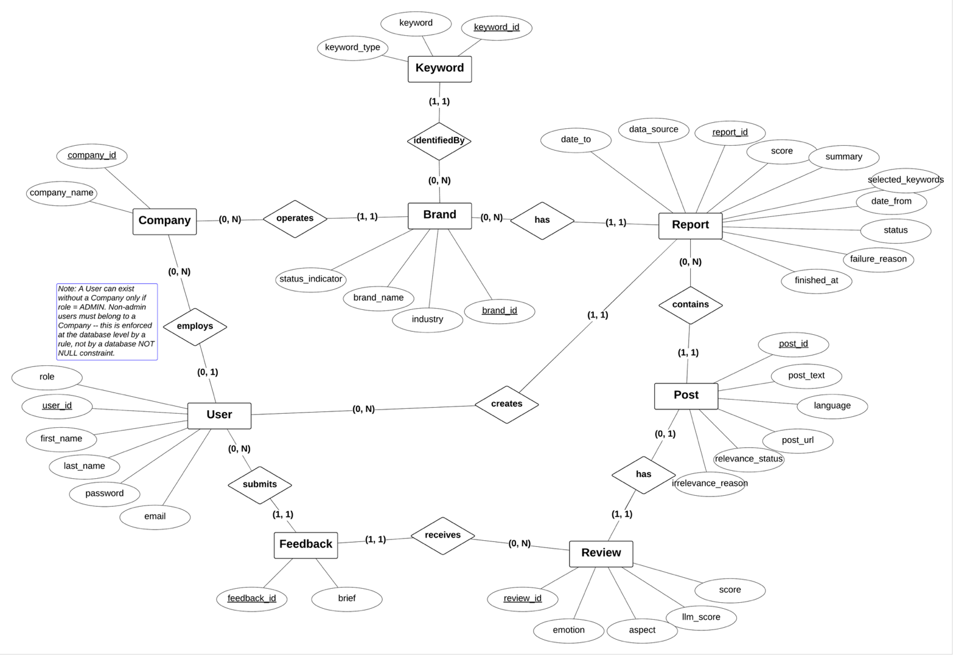
Figure 17: Entity-Relationship Diagram

4.2.5 Relational Model
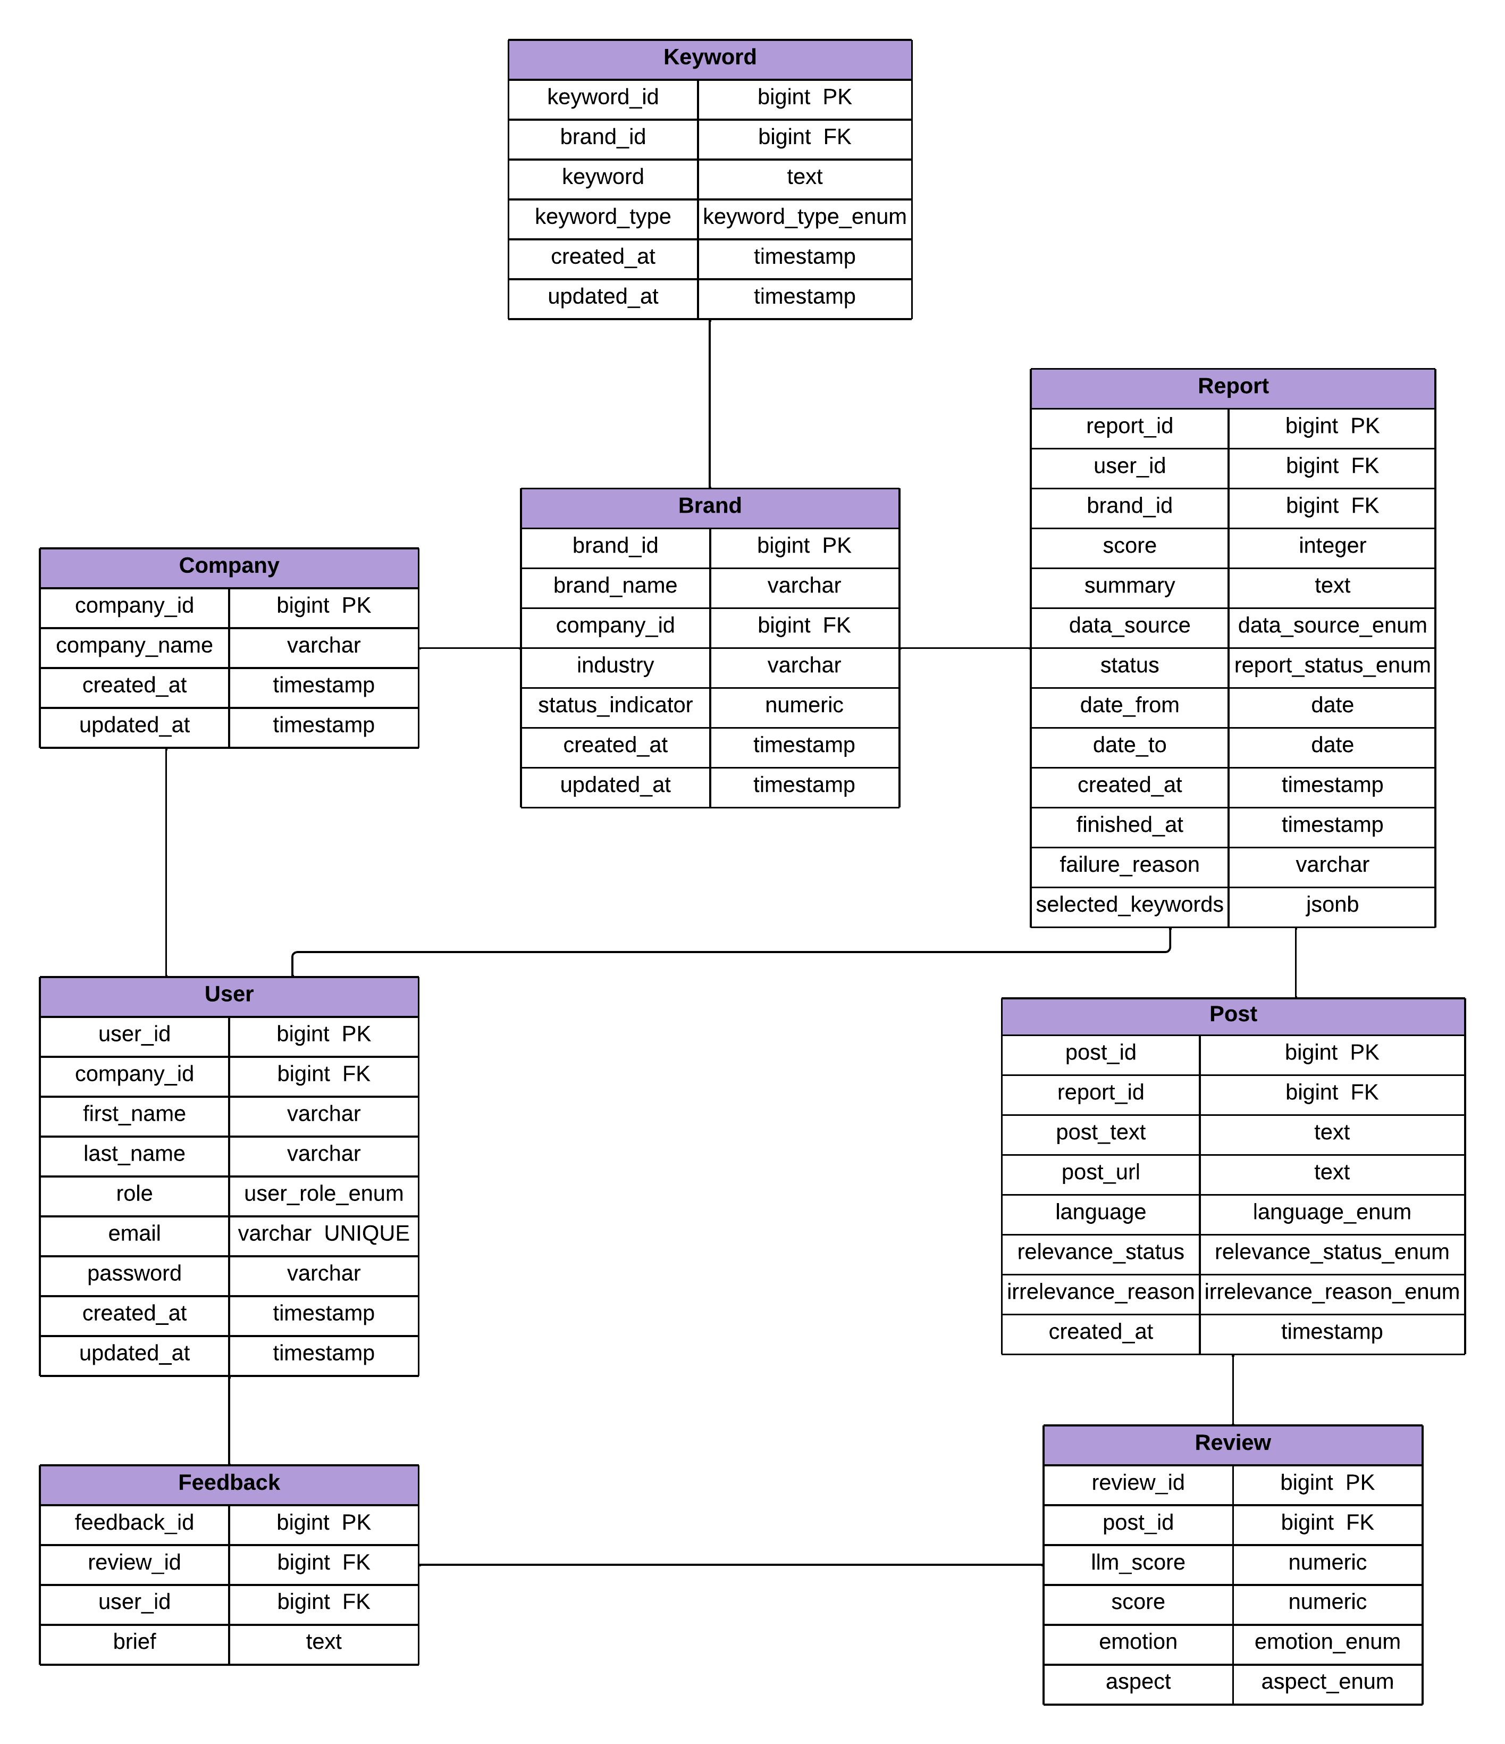
Figure 18: Relational Model

4.2.6 UI Mockups
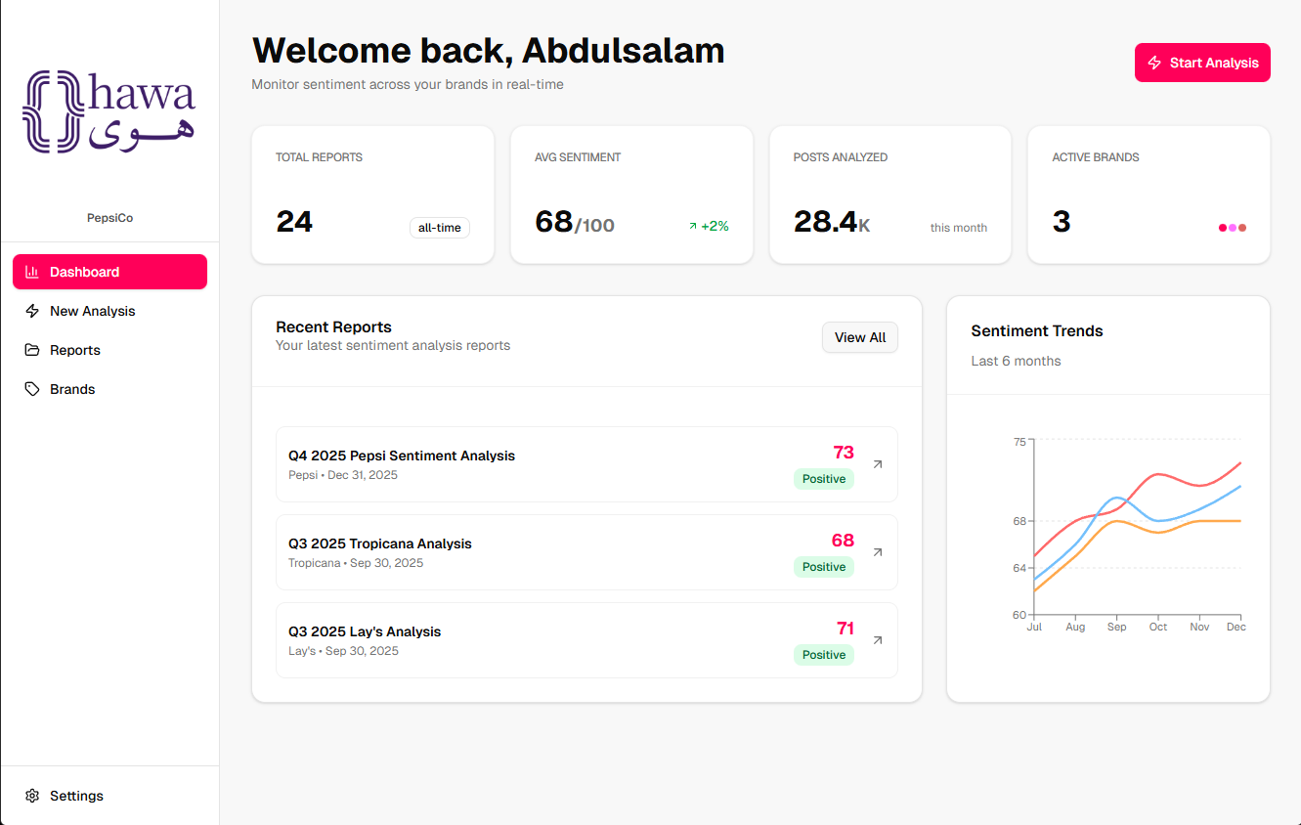
Figure 19: Main Dashboard View
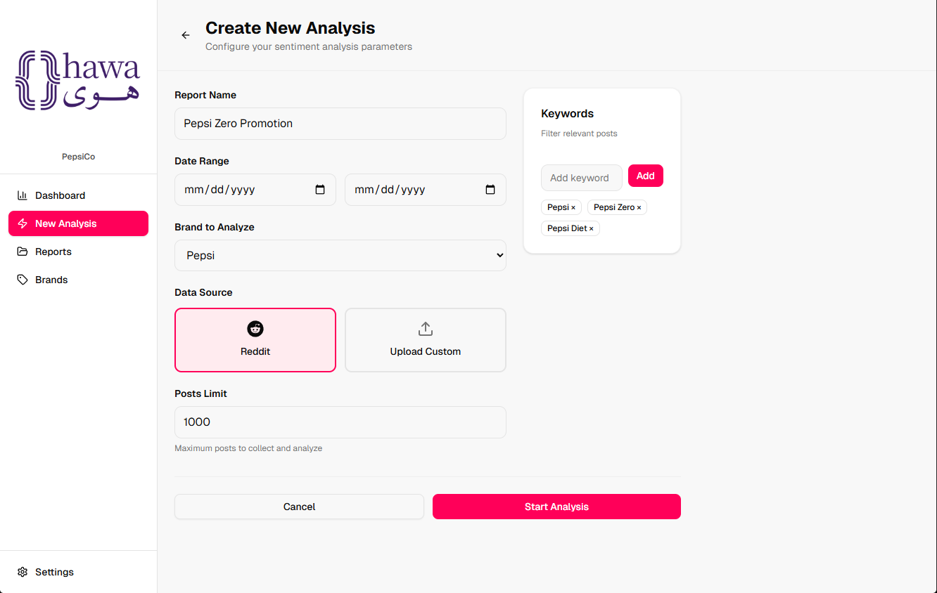
Figure 20: Start Analysis View

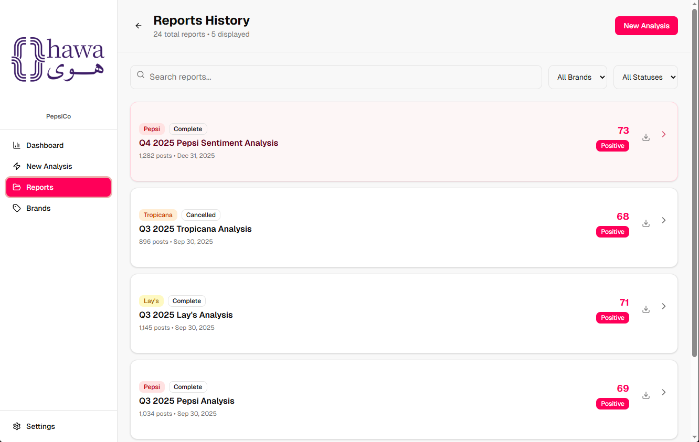
Figure 21: View Reports History View
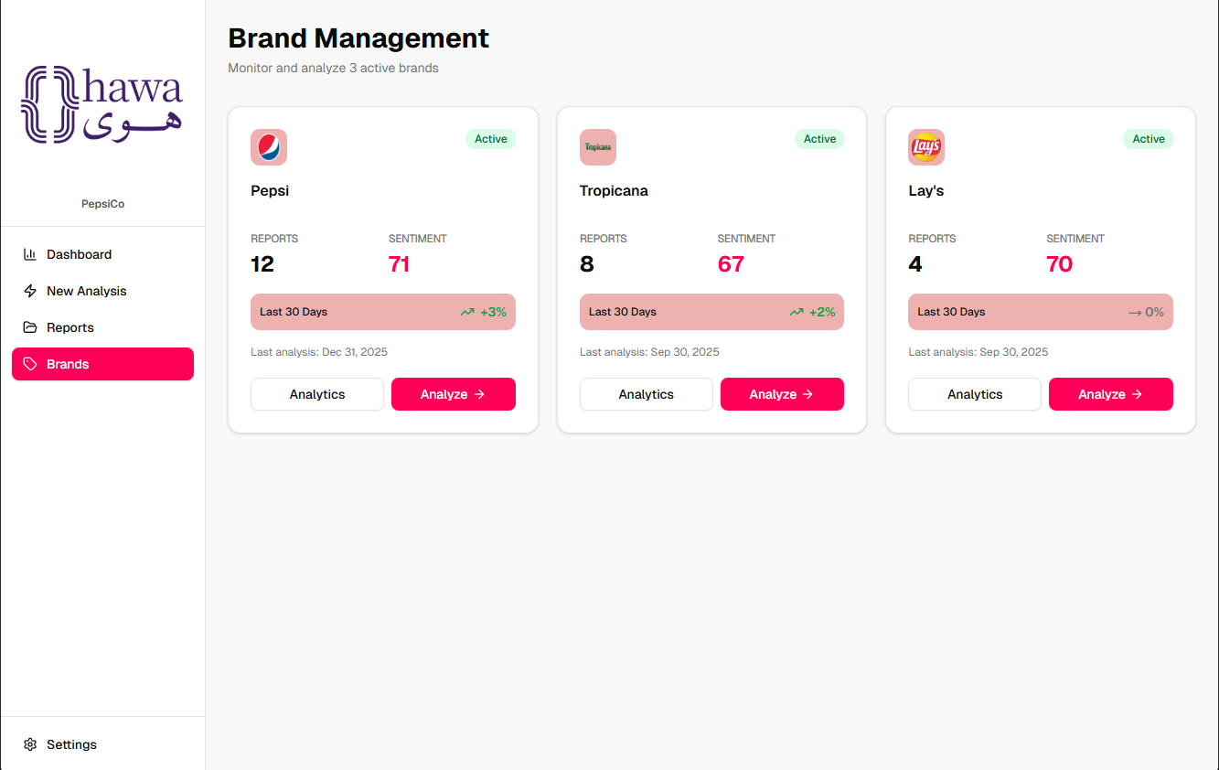
Figure 22: Brand Management View

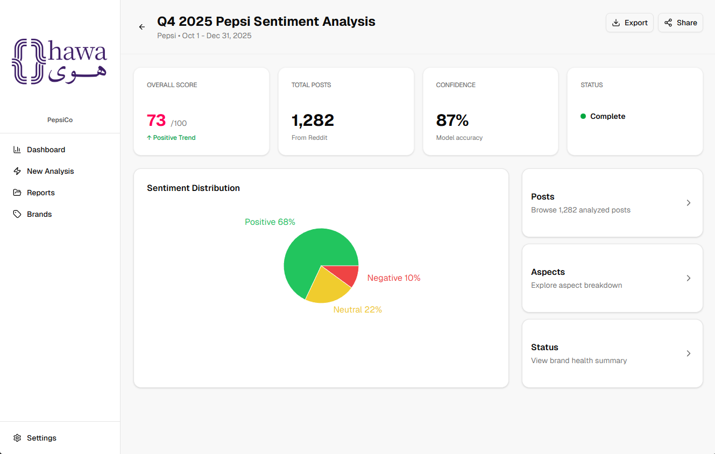
Figure 23: View Result View
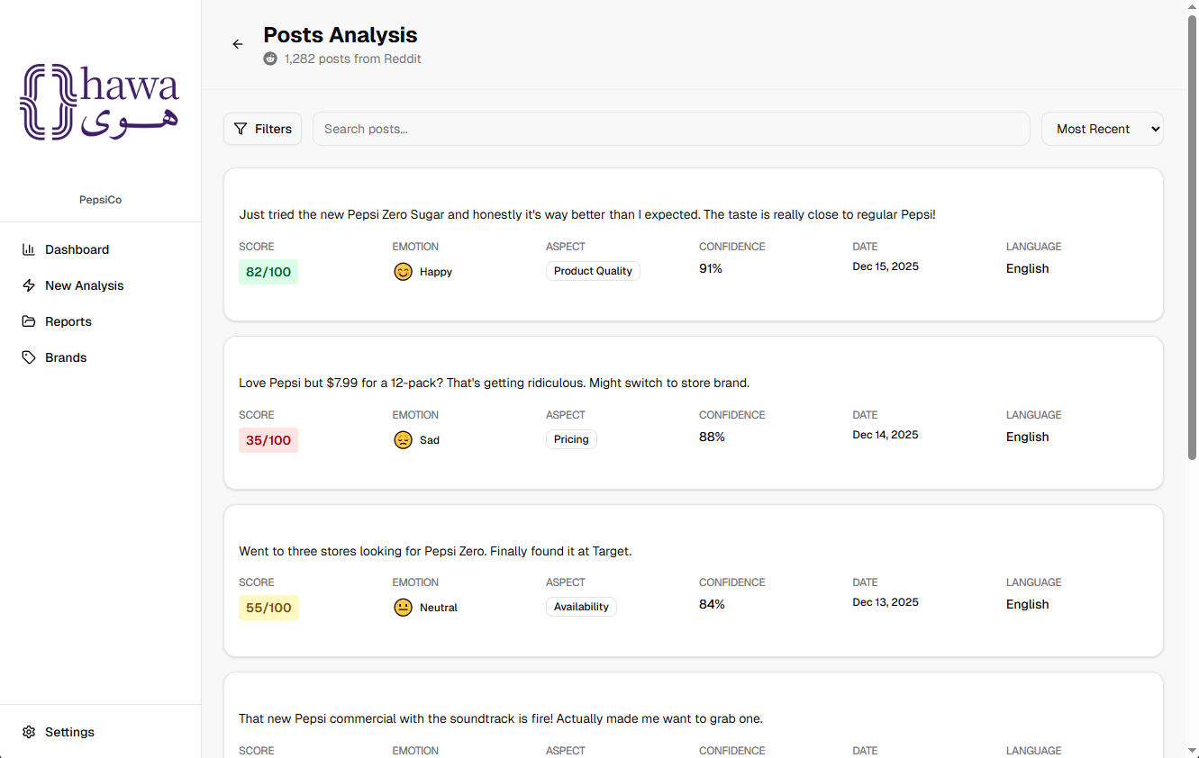
Figure 24: View Posts View

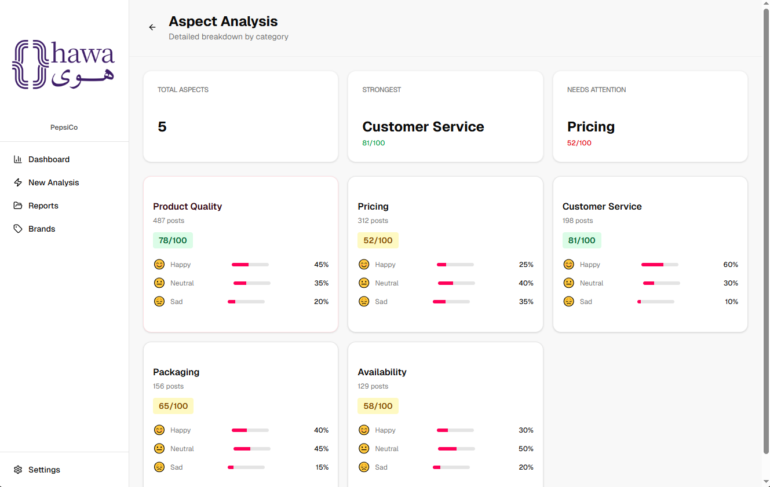
Figure 25: View Aspects View
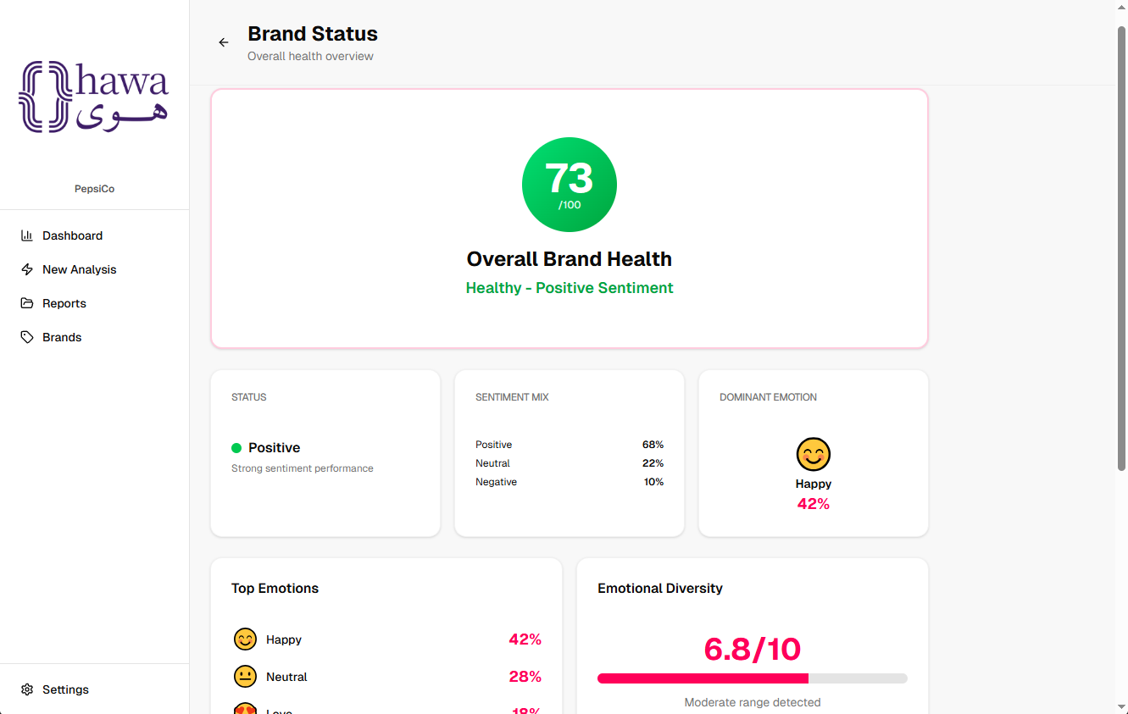
Figure 26: View Status Indicator View

Chapter 5: Evaluation of Selected Large Language Models
This chapter reports the empirical evaluation of the three open-weight large language models — Llama 3.3 70B Instruct, gpt-oss-120B, and Qwen2.5-72B-Instruct — on the Hawa sentiment-analysis task. Each model is assessed under three prompting regimes (zero-shot, static few-shot, and retrieved few-shot) over a manually labelled English social-media control set of 400 posts. Quality is measured along four label dimensions of the Hawa schema: relevance, sentiment score, emotion, and aspect. Cells are compared on the intersection set of 261 posts that every model judged relevant, and the statistical significance of pairwise differences is established with paired bootstrap confidence intervals on score regression and McNemar exact tests on classification.

5.1 Benchmark Design

5.1.1 Research Question
The benchmark is structured around a single guiding question: among the three pre-selected open-weight models, which combination of model and prompting regime yields the best joint performance on Hawa’s multi-dimensional sentiment task, and under what efficiency cost. The question is framed as joint rather than per-metric, because the production system must emit all label dimensions for every post from a single inference call.

5.1.2 Experimental Matrix
The experimental design is a fully crossed 3 × 3 matrix of model and prompting regime, yielding nine experimental cells. The three regimes are defined uniformly across all models:
- Zero-shot. The model receives only the task instructions, the label taxonomy, and the test post. This regime measures the model’s prior knowledge and instruction-following ability without any in-context examples.
- Static few-shot. A fixed set of N labelled exemplars is prepended to every test prompt. The same exemplars are used for every test post, isolating the effect of in-context learning from a constant demonstration set.
- Retrieved few-shot. For each test post, the top N exemplars are selected from a held-out exemplar pool by cosine similarity in an embedding space. This regime tests whether targeted, semantically similar demonstrations improve performance over a fixed set.
All nine cells are executed against the same control dataset, with identical decoding parameters, identical preprocessing, and the same retrieval encoder where applicable, so that any observed differences are attributable to the model or the prompting regime rather than to incidental variation.

5.1.3 Control Dataset
The evaluation set consists of 400 English social-media posts drawn from a manually annotated control corpus. Each post carries four gold labels: a binary relevance flag (15 of 400 posts are labelled irrelevant), a continuous sentiment score in the range 0.0–5.0 for relevant posts, a single dominant emotion drawn from the production emotion taxonomy, and a single dominant aspect drawn from the production aspect taxonomy defined in apps/llm/models.py. The dataset is partitioned into k folds, and a separate held-out pool of exemplars is maintained for the few-shot regimes. The runner masks any exemplar that shares a fold with the test post, which prevents the inflation of few-shot results by self-leakage.

5.1.4 Fairness and Reproducibility Controls
Several controls are applied uniformly across all nine cells to ensure that the comparison is meaningful. Decoding is deterministic, with temperature fixed at 0.0 and top_p at 1.0. Structured output is enforced via JSON-mode (or its provider-specific equivalent) so that label extraction does not become a separate source of error. Preprocessing, prompt assembly, the rate limiter, and the analyzer service are imported from the production apps/llm package so that the benchmark exercises the same code paths that the live system will exercise. For gpt-oss-120B, reasoning effort is held at the low setting for parity with the two non-reasoning models. Every result row records the model identifier, the prompt-template hash, the dataset hash, the fold assignment, the code git SHA, and a timestamp, so that any cell in the headline table can be reproduced from the artefacts alone. The verbatim system prompt and the static / retrieved few-shot wrappers are reproduced in Appendix F.

5.2 Evaluation Methodology

5.2.1 Score Regression Metrics
The sentiment score is a continuous variable on the closed interval [0.0, 5.0], so the appropriate evaluation tools are regression metrics rather than classification metrics. Three are reported. Mean Absolute Error (MAE) summarises the average magnitude of prediction error in the original label units. Root Mean Squared Error (RMSE) penalises large errors more heavily than MAE and is reported alongside it to expose tail-error behaviour. Pearson correlation coefficient r captures the linear relationship between predicted and gold scores; it is invariant to additive and multiplicative bias and therefore complements MAE by isolating ranking quality from calibration. MAE is accompanied by a 95% confidence interval estimated by paired bootstrap resampling over 1000 iterations.

5.2.2 Classification Metrics
Emotion, aspect, and relevance labels are categorical, and the emotion and aspect taxonomies are non-uniform in class frequency. Two metrics are reported per categorical dimension. Accuracy is the fraction of posts on which the predicted label matches the gold label and is included for transparency. Macro-averaged F1 is the unweighted mean of per-class F1 scores; it is the headline classification metric, because it weights every class equally and is therefore robust to class imbalance. For relevance, both the overall F1 and the per-class precision and recall on the irrelevant class are reported separately, because precision and recall on the minority irrelevant class are diagnostic of a model’s calibration.

5.2.3 Significance Testing
Point estimates alone are insufficient for an academic comparison. To support claims of superiority between cells, pairwise differences are tested with two procedures. McNemar’s exact test is computed on paired emotion-accuracy predictions and reports a two-sided p-value. Differences in MAE are tested by paired bootstrap resampling over 1000 iterations, which produces a 95% confidence interval on the difference; a difference is considered significant when the interval excludes zero. The full pairwise matrix of 36 comparisons is computed and stored in summary_pairwise.csv; the most consequential rows are reproduced in Appendix D.

5.2.4 Relevance and Coverage
Each model first decides whether a post is relevant to brand sentiment, and only emits a score, emotion, and aspect for posts it judges relevant. The coverage of a cell is defined as the fraction of the 400 control posts on which the model produced any non-irrelevant prediction; uncovered posts are not format-compliance failures but deliberate relevance decisions. Coverage therefore varies substantially between cells — from 70.5% for gpt-oss-120B static few-shot to 96.3% for Llama 3.3 70B static few-shot — and is reported as a column of the headline table. The accuracy of the relevance decision itself is evaluated against the 15 gold-irrelevant posts in the control set and reported as a separate label dimension.

5.2.5 Intersection Set
Because coverage varies between cells, per-cell metrics computed on each cell’s own predicted subset are not directly comparable: a cell that filters out the hardest posts will appear to score higher on score regression and classification metrics, even when its underlying model is no stronger. To enable a strict apples-to-apples comparison, the score, emotion, and aspect metrics in the headline table are computed on the intersection of all nine cells — the 261 posts that every cell judged relevant — using the precomputed intersection columns in summary.csv. Full-coverage metrics, which reflect each cell’s behaviour as deployed, are reported in Appendix A alongside the intersection variant for transparency.

5.3 Results
Table 5.1 reports the nine experimental cells on the intersection set of 261 consensus-relevant posts. Score MAE, emotion macro-F1, and aspect macro-F1 are computed on the intersection set. Coverage is the fraction of the full 400-post evaluation that each cell predicted on. Relevance macro-F1 is computed on the full 400 posts, since the relevance decision is made for every post by every cell. Pearson r is computed on each cell’s own predicted set, since it is invariant to subset size and is reported for completeness. Best results in each column are reported in bold.
Model | Regime | Coverage | MAE | Pearson r | Emo F1 | Asp F1 | Rel F1
Llama 3.3 70B | Zero-shot | 96.0% | 0.418 | 0.883 | 0.497 | 0.811 | 0.986
Llama 3.3 70B | Static few-shot | 96.3% | 0.354 | 0.895 | 0.552 | 0.797 | 0.985
Llama 3.3 70B | Retrieved few-shot | 95.8% | 0.358 | 0.893 | 0.529 | 0.836 | 0.981
gpt-oss-120B | Zero-shot | 79.0% | 0.412 | 0.865 | 0.442 | 0.765 | 0.900
gpt-oss-120B | Static few-shot | 70.5% | 0.389 | 0.886 | 0.463 | 0.811 | 0.846
gpt-oss-120B | Retrieved few-shot | 85.3% | 0.414 | 0.868 | 0.520 | 0.830 | 0.937
Qwen2.5-72B | Zero-shot | 90.3% | 0.356 | 0.900 | 0.362 | 0.771 | 0.968
Qwen2.5-72B | Static few-shot | 96.0% | 0.339 | 0.916 | 0.388 | 0.815 | 0.994
Qwen2.5-72B | Retrieved few-shot | 96.0% | 0.312 | 0.897 | 0.401 | 0.778 | 0.988
Table 14: Headline benchmark results on the intersection set of n = 261 consensus-relevant posts. MAE, Emo F1, and Asp F1 are computed on the intersection set. Coverage and Rel F1 are computed on the full 400-post evaluation. Pearson r is computed on each cell’s own predicted set. Best per column in bold.
Three observations follow from Table 5.1. First, Llama 3.3 70B static few-shot pareto-dominates the matrix on the joint quality-coverage objective: it attains the highest emotion macro-F1 (0.552), the highest coverage (96.3%), the lowest end-to-end p95 latency in the matrix (1.28 s, see Section 5.6), and is within 0.04 macro-F1 of the per-dimension winner on aspect and relevance. No other cell achieves all three of competitive emotion, competitive aspect, and sub-1.5 s latency. Second, the per-dimension winners do not coincide: Qwen2.5-72B retrieved few-shot wins on score regression (MAE 0.312), Llama 3.3 70B retrieved few-shot wins on aspect (macro-F1 0.836), and Qwen2.5-72B static few-shot wins on relevance (macro-F1 0.994) and Pearson correlation (0.916). The trade-off space is real, and the production model choice depends on which dimension the deployed feature surfaces to the user. Third, coverage varies between 70.5% and 96.3% across cells, and this variation is itself a signal of model calibration on the relevance decision, examined in Section 5.4.4.
Two pairwise significance results anchor the claims above. Llama 3.3 70B static few-shot beats Qwen2.5-72B static few-shot on emotion accuracy with McNemar p = 8.9 × 10⁻⁷ (60 wins, 17 losses out of 77 disagreements on the intersection set), and beats gpt-oss-120B static few-shot on the same metric with p = 1.2 × 10⁻⁴. Qwen2.5-72B retrieved few-shot beats gpt-oss-120B retrieved few-shot on MAE with bootstrap difference CI of [0.046, 0.155] (point estimate 0.102, p = 0.002). The full pairwise table appears in Appendix D.

5.4 Findings by Label Dimension

5.4.1 Sentiment Score
Qwen2.5-72B-Instruct is the strongest model on the regression component of the task. Its retrieved few-shot cell attains the lowest intersection-set MAE in the matrix (0.312), and its static few-shot cell attains the highest Pearson correlation (0.916). The two Qwen cells are statistically indistinguishable on full-coverage MAE: the paired bootstrap difference CI is [-0.012, 0.069] with point estimate 0.027). The advantage of Qwen on the score dimension is consistent with the model’s reputation for numerical reasoning in the Qwen2.5 technical report and is preserved across all three regimes, which suggests that the effect is rooted in pre-training rather than in prompting. Llama 3.3 70B trails the best Qwen cell by approximately 0.04 MAE on the intersection set, and gpt-oss-120B trails by approximately 0.08 MAE while also exhibiting the highest tail-error variance through its RMSE.

5.4.2 Emotion Classification
Llama 3.3 70B is the strongest model on emotion classification, and the advantage is statistically robust. On the intersection set, Llama 3.3 70B static few-shot attains macro-F1 0.552 and Llama 3.3 70B retrieved few-shot attains 0.529, both more than 0.10 above the best Qwen cell (static few-shot, 0.388) and more than 0.03 above the best gpt-oss-120B cell (retrieved few-shot, 0.520). The Llama–Qwen gap on emotion accuracy is significant under McNemar at p = 8.9 × 10⁻⁷ for the static-few-shot pair, and the Llama–gpt-oss gap at p = 1.2 × 10⁻⁴. The combination of relatively high emotion accuracy (0.47–0.50) with low emotion macro-F1 (0.37–0.40) at Qwen indicates a model that classifies majority emotion classes well but performs poorly on minority emotions, an interpretation supported by the per-class confusion matrices stored alongside each parquet.

5.4.3 Aspect Classification
Llama 3.3 70B retrieved few-shot is the strongest cell on aspect classification on the intersection set (macro-F1 0.836), with gpt-oss-120B retrieved few-shot a close runner-up at 0.830 and Qwen2.5-72B static few-shot at 0.815. The retrieved-few-shot regime is the strongest regime for aspect across every model, consistent with the literature on aspect-based sentiment analysis, in which targeted exemplars consistently improve performance because aspect labels in social-media text are linguistically subtler than emotion or polarity labels. The aspect dimension also exhibits the largest absolute regime effect: moving from zero-shot to retrieved few-shot shifts aspect macro-F1 by 0.025 to 0.071 across the three models.

5.4.4 Relevance Detection
Relevance is a fourth label dimension on which the three models exhibit qualitatively different behaviour. Overall relevance macro-F1 ranks Qwen2.5-72B static few-shot first (0.994), followed by Qwen2.5-72B retrieved few-shot (0.988) and Llama 3.3 70B zero-shot (0.986). However, the headline metric conceals a meaningful calibration story that is best read through the per-class precision and recall on the minority irrelevant class:
- Llama 3.3 70B under-flags irrelevance. Its recall on the 15 gold-irrelevant posts ranges from 0.13 (retrieved few-shot) to 0.33 (zero-shot), meaning the model frequently produces a sentiment score for posts that the gold standard considers off-topic. Its precision is high when it does flag (0.50–1.00), but downstream consumers of Llama predictions see contaminated brand-level aggregates.
- gpt-oss-120B over-flags irrelevance. Its precision on irrelevant predictions ranges from 0.13 (few-shot) to 0.23 (retrieved few-shot), meaning roughly four in five of its irrelevant calls are wrong. Recall is high, but the consequence is the dramatic drop in coverage observed in Table 5.1, where the model discards as much as 29.5% of the evaluation set on its own initiative.
- Qwen2.5-72B static few-shot is the best-calibrated relevance judge. Its irrelevant-class recall is 0.73 and its irrelevant-class precision is 0.92, giving the highest joint score on the minority class. Together with its 96.0% overall coverage, Qwen static is the only cell that combines high coverage with a credible relevance filter.
The operational implication is that relevance macro-F1 alone is misleading: a high overall F1 is easy to achieve when the irrelevant class is small, and the precision–recall breakdown is the dimension that determines whether the downstream sample is biased. For the production system, this argues either for adopting Qwen’s relevance behaviour wholesale or for adding a thin auxiliary relevance classifier that overrides the primary model’s decision when the two disagree.

5.5 Effect of Prompting Regime
Holding the model fixed, the prompting regime exerts a smaller but systematic effect. Averaged across the three models on the intersection set, moving from zero-shot to static few-shot reduces MAE by 0.024 (from 0.395 to 0.361), raises emotion macro-F1 by 0.034 (from 0.434 to 0.468), and raises aspect macro-F1 by 0.025 (from 0.782 to 0.808). Moving from static few-shot to retrieved few-shot has a more selective effect: it improves aspect macro-F1 by an additional 0.007 (averaged) and emotion macro-F1 by 0.016, but shows essentially no improvement on the score-regression metrics, where the static set already encodes the calibration distribution. Table 5.2 summarises the averaged regime effect across models.
Regime (averaged over 3 models, intersection set) | MAE | Pearson r | Emo F1 | Asp F1
Zero-shot | 0.395 | 0.883 | 0.434 | 0.782
Static few-shot | 0.361 | 0.899 | 0.468 | 0.808
Retrieved few-shot | 0.361 | 0.886 | 0.484 | 0.815
Table 15: Mean of each intersection-set metric over the three models, broken out by prompting regime. Static few-shot is the strongest regime on score regression; retrieved few-shot is the strongest on emotion and aspect classification.
A practical reading of Table 5.2 is that the two few-shot regimes target different parts of the task. Static few-shot disciplines the model’s numerical score output by exposing it to a fixed and well-calibrated reference distribution. Retrieved few-shot supplies semantically proximate examples for each post, which is particularly valuable on the categorical dimensions where the right label depends on subtle textual cues. This dissociation explains why the production analyzer ultimately benefits from a hybrid approach in which the same exemplar pool is used for static and retrieved regimes.

5.5.1 Worked example: one post across the three regimes
To make the regime effect concrete, this subsection traces a single control-set post through all three Llama 3.3 70B cells. The post is a short comparative statement about pricing; the gold label is score 4.0, emotion JOY, aspect PRICING. The three regimes produce three different outputs, and the differences are attributable to the in-context demonstrations injected by each regime, not to the underlying model. The verbatim system prompt and the wrapper templates are reproduced in Appendix F; this subsection only shows the demonstrations actually injected and the resulting predictions.
Post (id 278 in apps/benchmark/data/control.jsonl):
"I was set on getting an iPad Pro, but the price for a 512 GB MacBook Neo is just too good not to consider."
Gold: score = 4.0, emotion = JOY, aspect = PRICING.
Zero-shot.
No exemplars are appended; the model receives only the system prompt of Appendix F.1 followed by the post. The cell returns score = 3.5, emotion = SURPRISE, aspect = PRICING — the model reads “too good not to consider” as a moment of surprise rather than a settled positive preference, and slightly undershoots the score.
Static few-shot.
The same ten labelled exemplars are prepended to every test post. The set is drawn from apps/benchmark/data/exemplars.jsonl (ids 10005, 10006, 10008, 10013, 10016, 10025, 10028, 10029, 10033, 10065) and is stratified to span the score range and the aspect taxonomy. The exemplars appear in the prompt in the format documented in Appendix F.2. The cell returns score = 3.0, emotion = SURPRISE, aspect = PRICING — the fixed exemplar set actually pulls the score below zero-shot, because the static set is dominated by mid-scale PRODUCT exemplars rather than enthusiastic PRICING examples that would anchor the model toward the gold JOY/4.0 reading.
Retrieved few-shot.
The retriever selects the top k = 4 most similar exemplars by cosine similarity in the nomic-embed-text-v1.5 embedding space, with fold masking applied. For this post, the retrieved set is:
id 10063, score 2.5, FEAR, PRODUCT
“anyone else worried Apple is going to abandon iPad like they did iPod”
id 10059, score 4.0, JOY, PRODUCT
“Apple TV 4K with the new remote is genuinely the best streaming experience I've used”
id 10060, score 2.0, FEAR, PRODUCT
“afraid to give Apple my passport for the new digital ID feature, but everyone says it's fine”
id 10001, score 4.5, JOY, PRODUCT
“iPhone 17 Pro camera in low light is genuinely amazing, night mode finally lives up to the marketing”
The retrieved set is mixed: two of the four exemplars (10059, 10001) carry JOY at scores 4.0 and 4.5 and share the test post’s “genuinely too good” enthusiastic frame; the remaining two are FEAR-labelled and were retrieved on lexical overlap with “iPad” rather than semantic alignment. The cell returns score = 4.0, emotion = JOY, aspect = PRICING — all three dimensions match gold. The two JOY exemplars are sufficient to flip the emotion from SURPRISE to JOY and to recover the +0.5 score that static had lost relative to zero-shot. The PRICING aspect is stable across all three regimes because none of the exemplars in any regime are PRICING-labelled; the aspect call is the model’s own.
Summary table for post 278 (Llama 3.3 70B):
regime | score | emotion | aspect
zero-shot | 3.5 | SURPRISE | PRICING
static few-shot | 3.0 | SURPRISE | PRICING
retrieved fs | 4.0 | JOY | PRICING
gold | 4.0 | JOY | PRICING
The worked example illustrates the dissociation described above: static few-shot disciplines the score scale on average but is blind to the specific test post, and on this row it drifts further from gold than the zero-shot baseline. Retrieved few-shot can correct an under-confident categorical prediction when the retrieved neighbours are semantically aligned, even when only a subset of the retrieved set matches the gold label.

5.6 Efficiency Analysis
Quality alone does not determine the production choice, because every prompt directly incurs a token cost and every inference contributes to the queue depth of the analyzer service. The benchmark therefore tracks both end-to-end latency and token consumption per post. The relevant trade-off is captured compactly in Table 5.3.
Cell | p50 (ms) | p95 (ms) | Tokens / post | Headline F1*
Llama 3.3 70B, static few-shot | 859 | 1276 | 1454 | 0.552 / 0.797
Llama 3.3 70B, retrieved few-shot | 4171 | 8134 | 1410 | 0.529 / 0.836
gpt-oss-120B, static few-shot | 1927 | 3082 | 1939 | 0.463 / 0.811
gpt-oss-120B, retrieved few-shot | 4414 | 7647 | 1933 | 0.520 / 0.830
Qwen2.5-72B, static few-shot | 2029 | 2338 | 1454 | 0.388 / 0.815
Qwen2.5-72B, retrieved few-shot | 4673 | 7683 | 1401 | 0.401 / 0.778
Table 16: Efficiency profile of the few-shot cells. Headline F1* lists intersection-set emotion macro-F1 and aspect macro-F1, separated by a slash. Llama 3.3 70B static few-shot is the only cell with a p95 latency below 1.5 seconds.
Two findings stand out. The Llama 3.3 70B static-few-shot cell is the only cell with a p95 latency below 1.5 seconds and is competitive on every quality dimension. Retrieved few-shot consistently imposes a three- to five-fold latency penalty across all three models, which traces to the extra embedding and similarity-search step rather than to the LLM call itself. For most production paths in Hawa — where posts are analyzed in batches off the user-facing critical path — the latency of retrieved few-shot is acceptable, but for any interactive or near-real-time path the static regime is preferred.

5.7 Error Analysis
Quantitative metrics summarise the behaviour of each cell, but they conceal the linguistic phenomena that drive errors. A qualitative analysis was conducted on a stratified sample of misclassified posts drawn from the highest-performing cells of each model. Four recurring categories of error were observed.

5.7.1 Sarcasm and Implicit Sentiment
All three models systematically mishandle posts in which the surface sentiment of the text contradicts the speaker’s intent. A representative example is a post praising a product with elaborate compliments while the surrounding context (a thread title, an emoji-light closing line) signals sarcasm; all three models assign a sentiment score in the 4.0–4.5 range against a gold value of 1.0. Retrieved few-shot reduces but does not eliminate this failure mode, because the retrieval index encodes semantic similarity rather than pragmatic similarity.
Two posts from the control set make the failure mode concrete.
Post 169 (“I won’t come back to non air. They feel like a brick compared to the air”) carries gold score 1.0 (negative, comparing the standard iPhone to the iPhone Air using “brick” as a pejorative). Llama 3.3 70B zero-shot scores 1.0 correctly, but its static-few-shot cell jumps to 4.0 and its retrieved-few-shot cell to 4.5 — both few-shot regimes amplify a positive reading of “air” that the exemplar set has anchored. Only Qwen2.5-72B static few-shot (1.5) recovers the negative polarity.
Post 379, an extended complaint about iCloud pricing (“I hate the fact that I have to pay, every month for icloud... it is never ending... you have to pay every month for your ENTIRE LIFE”), carries gold score 2.0, emotion DISGUST, aspect PRICING. Both Llama 3.3 70B static and retrieved few-shot return 4.0 / JOY / PRODUCT because the post pivots to a promotional pitch for the author’s own iOS app in the second half; the model weights the trailing positive frame and ignores the leading complaint. gpt-oss-120B (1.5 / ANGER / PRICING) handles this post correctly across all three regimes.

5.7.2 Mixed-Aspect Posts
Posts that comment on more than one aspect of a brand — for example, praising delivery while criticising the product itself — are routinely collapsed to a single aspect by all three models, in line with the single-label production schema. The model’s choice of which aspect to surface is inconsistent and is driven less by importance and more by recency in the post. This finding is the single strongest argument in favour of extending the production schema to multi-label aspect prediction in a subsequent iteration.
Post 181 (“The air is nice, I’m currently using it... For $100 more the 17 pro is so much better... value isn’t there... it doesn’t live up to the price tag”) carries gold aspect PRICING. The post unambiguously discusses both product quality and price, but Llama 3.3 70B retrieved few-shot (the aspect winner overall) returns aspect = PRODUCT, collapsing to the first-mentioned axis.
Post 134 (“Good price tbh. Having an phone and tablet all in one is pretty sick imo. I won’t be buying one because I already own an iPad but looks like a super cool phone!”) carries gold aspect PRICING. The opening “Good price tbh” is the dominant signal in the post, but the same Llama retrieved few-shot cell collapses to PRODUCT because the remainder of the post enumerates product characteristics. Five further misclassifications of the same shape (post ids 173, 212, 219, 251, 316) appear in the same cell, all bound to PRICING→PRODUCT or PRICING→BRAND drift.

5.7.3 Code-Switching
Although the control set is nominally English, a small fraction of posts contain code-switching with transliterated Arabic terms or product names. Qwen2.5-72B handles these posts with the highest fidelity, consistent with its bilingual pre-training. Llama 3.3 70B and gpt-oss-120B occasionally hallucinate aspect labels that map plausibly to the English fragment of the post while ignoring the more salient Arabic fragment.
Observed instances in the control set.
The 400-post control set is filtered to English at collection time and, after preprocessing, contains no posts with substantive Arabic-script content; the non-ASCII content that does appear is either emoji or mojibake from the original capture pipeline (e.g. post 264, post 276, post 370). Consequently, the code-switching failure mode is described from the project’s pilot dataset and from the literature on multilingual ABSA (Wu et al., 2024) rather than from the 400-post benchmark. A dedicated Arabic and Arabic–English code-switching evaluation is identified in Chapter 7 as a primary direction for future work.

5.7.4 Relevance-Classification Behaviour
The coverage column in Table 5.1 quantifies a behavioural difference that is invisible in the headline quality metrics. gpt-oss-120B labels as much as 29.5% of the control set as irrelevant in its static few-shot configuration, while Llama 3.3 70B in the same regime labels only 3.7% as irrelevant. This is not a failure of format compliance; both models return parseable JSON in all 400 cases. It is a difference in the threshold at which each model considers a post worth analyzing. Section 5.4.4 establishes that gpt-oss-120B’s precision on the irrelevant class is 0.13–0.23, meaning the model discards posts that the gold standard considers relevant; Llama’s recall on the same class is 0.13–0.33, meaning the model retains posts that the gold standard considers irrelevant. Both behaviours bias the downstream sample, in opposite directions. The most calibrated cell on this dimension — Qwen2.5-72B static few-shot — exhibits 0.73 recall and 0.92 precision on the irrelevant class.
Example post
Post 120 (“This is a really common bug in all kinds of software. I had a whole Datacenter’s monitoring go down...”) is gold-labelled irrelevant (the post is about server-monitoring software, not the brand). Llama 3.3 70B static few-shot accepts it and emits score 1.0, while Qwen2.5-72B and gpt-oss-120B in the same regime both correctly reject it. The same one-way disagreement appears on three other posts (90, 113, 117). The over- and under-flagging behaviours bias the downstream sample in opposite directions; both are visible in the precision–recall breakdown of Section 5.4.4.

5.8 Model and Regime Selection for Production
Taken together, the quality and efficiency results identify a single cell that dominates the matrix on the joint objective of competitive accuracy on every dimension, high coverage, and low latency. The recommendation is as follows.
- Primary production model: Llama 3.3 70B Instruct in static few-shot. It wins emotion macro-F1 (0.552 on the intersection set), wins p95 latency (1276 ms, the only sub-1.5 s cell), wins coverage (96.3%), and is within 0.04 macro-F1 of the per-dimension winners on aspect (0.797 vs. 0.836) and relevance (0.985 vs. 0.994). No other cell is competitive across all of these dimensions simultaneously. The McNemar tests against the runner-up cells on emotion accuracy yield p-values in the range 10⁻⁴ to 10⁻⁷, confirming that the emotion advantage is statistically robust.
- Score-sensitive workloads: Qwen2.5-72B-Instruct in static few-shot is preferred when the deployed feature surfaces the numerical sentiment score directly to the user. Its 0.339 intersection-set MAE and 0.916 Pearson correlation are the best in the matrix, and its 0.994 relevance macro-F1 with well-calibrated minority-class precision-recall makes it the most defensible choice for any aggregated brand-status indicator that the dashboard derives from individual scores.
- Aspect-sensitive workloads: Llama 3.3 70B in retrieved few-shot is preferred when the deployed feature consumes the aspect label downstream, for example in aspect-segmented reports. Its 0.836 intersection-set aspect macro-F1 is the best in the matrix, with gpt-oss-120B retrieved few-shot a close second (0.830). The advantage over the primary Llama static cell is 0.039 macro-F1, which must be weighed against the six-fold p95 latency penalty (8134 ms vs. 1276 ms).
A hybrid configuration in which Llama 3.3 70B static few-shot is the default and a second cell is invoked for posts where the primary cell is uncertain — or where the dashboard surface requires the stronger per-dimension cell — is technically feasible within the existing analyzer service, but is left for future work. The single-model recommendation above is sufficient for the capstone deliverable.

Chapter 6: Implementation & Testing

6.2 Hardware and Software Resources
Hawa was developed on standard developer laptops with no on-premises infrastructure. The database is hosted on Supabase and LLM inference is served from RunPod, so no server provisioning was required from the team.

6.2.1 Hardware
The project's hardware footprint is limited to the four developers' personal laptops, which were used for coding, testing, and report writing. No dedicated servers or GPU hardware were procured or operated by the team; all production workloads run on managed third-party services.

6.2.2 Software
The software stack is organised by service.
Backend — Java 25, Spring Boot 4.0.3, Spring Security, Spring Data JPA / Hibernate, Liquibase, PostgreSQL JDBC driver, jjwt, Maven.
Frontend — Node.js 24, React 19, Tailwind CSS 4, Vite, React Router 7, Fetch API.
LLM service — Python 3.12+, FastAPI.
Database — Supabase (managed PostgreSQL 17.6).
External APIs — RunPod (hosted LLM inference), Groq API (used during development), Reddit API (data source, accessed via PRAW).
Testing — JUnit 5, Mockito, Testcontainers, AssertJ.
Tooling — Git/GitHub, ClickUp, Jupyter Notebook, Streamlit, draw.io, Mermaid, IntelliJ IDEA, VS Code.

6.3.1 Repository Structure
The project is organised as a monorepo. All application code lives under apps/, with one folder per service.
hawa/
└── apps/
├── backend/ # Spring Boot 4 REST API (Java 25, Maven)
├── frontend/ # React 19 SPA (TypeScript, Vite 7)
├── llm/ # FastAPI sentiment analysis service (Python)
└── benchmark/ # LLM prompt/model evaluation harness (Python)
The four application services are developed and run independently. The backend (Spring Boot) exposes a REST API consumed by the frontend (React) and orchestrates calls to the LLM service (FastAPI), which in turn integrates with RunPod, Groq, and Reddit. The benchmark project is a standalone Python harness used to evaluate prompt and model variants; it is not part of the production runtime and is described.

6.3.2 Build and Run
Each service is built and run independently from its own directory under apps/.
Backend: Spring Boot
./mvnw spring-boot:run # runs in port 8080
The backend requires a running PostgreSQL instance during local development; the production database is hosted on Supabase. CORS is open for http://localhost:5173 to allow the local frontend dev server.
Frontend: React + Vite
npm install
npm run dev # dev server, proxies /api to localhost:8080
npm run build # production build to dist/
LLM service — FastAPI
pip install -r requirements.txt
uvicorn main:app --reload --port 8001

Chapter 7: Conclusion

7.1 Challenges

Arabic support is harder than expected:
We initially planned to support both English and Arabic, but Arabic turned into a major challenge. Many general-purpose LLMs still perform noticeably worse on Arabic than on English, especially for dialectical and informal social-media text. On top of that, there is no widely accessible social-media data source that both has a large Arabic text audience and provides an affordable, convenient API for bulk analysis (see Challenge 2). As a result, we treated Arabic support as a stretch goal instead of a guaranteed, production-quality feature in this phase.

Social media data access for Arabic (X is out of reach):
The most important Arabic text-based social media platform for public discussions is X (Twitter). However, X’s current API pricing, strict rate limits, and anti-scraping measures make it effectively out of reach. Free or low-cost options do not provide enough volume to build a realistic dataset, and unofficial scrapers are unreliable or blocked. Because of this, we had to abandon X as a data source, even though it is central for Arabic conversations, and instead rely on Reddit (which is more English-focused) and manual CSV/XLSX uploads. This directly limits how representative our analysis can be for Arabic-speaking users and brands.

Hardware limitations for local LLMs:
Our available hardware could only handle relatively small open-source models (around 3B–7B parameters) with acceptable latency and memory usage. Larger models either could not run at all or required heavy quantization that hurt quality. Practically, this forced us to use a smaller local model for the prototype and to evaluate only a small subset of posts for some open-source models. As a result, our comparison between local and cloud LLMs is constrained and does not fully show what might be achievable with stronger hardware.

7.2 Conclusion
The project delivers an LLM-based sentiment analysis prototype (Hawa) that processes social media data and uploaded datasets to extract multiple dimensions from each post: a sentiment score, a dominant emotion, and a brand-related aspect. These results are aggregated into dashboards and reports that summarize brand status over time, including aspect and emotion breakdowns. The implemented system covers the full pipeline from data ingestion (Reddit and CSV/XLSX) through LLM-based analysis to visualization in a web-based interface. Experiments on a small labeled dataset show that LLMs can perform multi-dimensional sentiment analysis with reasonable accuracy on English social media posts under careful prompt design and structured output formats. Some production LLMs achieved relatively low error on sentiment scores, indicating that they are viable engines for this type of analysis in constrained settings. In parallel, the architecture separates the LLM service, job queue, backend, and frontend, making it possible to swap models or extend data sources without redesigning the entire system. However, several important limitations remain. Most importantly, Arabic support proved significantly harder than English. General-purpose LLMs often perform worse on Arabic—especially informal, dialect-rich social-media text—while the main Arabic text platform with a large audience (X/Twitter) is currently inaccessible for realistic bulk analysis due to API limits, pricing, and anti-scraping measures. As a result, the current system focuses on English first, and Arabic is treated as a stretch goal rather than a fully delivered feature in this phase. In addition, hardware constraints restricted experiments with larger open-source models, and the evaluation dataset is too small to claim strong, general conclusions about performance in real-world conditions.
These limitations shape the next steps for future work:
- Arabic-focused evaluation and support
Build a dedicated evaluation pipeline for Arabic using realistic regional data, and compare multiple Arabic-capable LLMs and specialized sentiment models. Based on these experiments, select or combine models that provide acceptable accuracy and stability for Arabic posts, or adopt a hybrid architecture where English and Arabic use different backends.
- Experiments with larger cloud-hosted LLMs (vLLM setups)
Experiment with larger models hosted on the cloud (for example, via vLLM-based deployments or managed LLM providers) to see whether they can deliver better sentiment, emotion, and aspect predictions, especially for Arabic. These experiments should consider not only accuracy but also latency and cost, to understand what is realistically achievable if Hawa is scaled beyond a purely local setup.

7.3 Social, Ethical, Legal, Global, and Security Impact

1. Social Impact:
The system helps organizations turn large volumes of unstructured text into clearer signals about customer satisfaction, complaints, and recurring issues. This can support faster reactions to problems, more informed decisions, and more customer focused services.
At the same time, automated analysis can misread context, sarcasm, or sensitive topics. If teams trust the system without human review, they may misinterpret what users mean or overlook important individual feedback. The social impact therefore depends on using Hawa as support for human decision making, not as a full replacement for careful reading and direct communication with customers.

2. Ethical Impact
The main ethical concerns in this project are privacy and potential misuse. The system is designed for aggregate analysis at the level of brands and topics, using public data or datasets provided by organizations. It is not intended to profile or track specific individuals or to monitor them in a way that feels intrusive.
Hawa should be used to better understand customer needs and improve services, not to design manipulative campaigns or to silence criticism based only on sentiment scores produced by the model. For this reason, Hawa is positioned as a decision support tool, and the final responsibility for interpreting and acting on the results remains with human users.

3. Legal Impact
From a legal perspective, the system must respect data protection rules and the terms of use of each platform or data source. Public posts can still contain personal data, so the system should collect only what is necessary for analysis, avoid storing sensitive information without need, and apply reasonable retention and deletion practices, especially for uploaded datasets that may contain customer records.
The system should use official and allowed access methods for external platforms, and follow their usage policies. Organizations that upload their own datasets remain responsible for ensuring they have a lawful basis to process that data. Hawa supports them by providing controlled access and clear separation between different clients and projects.

4. Global Impact
In principle, Hawa can be used by organizations in different countries and regions. This makes it important that large scale analysis of public posts respects local expectations about privacy and acceptable data use, and that the system remains focused on aggregate insights about brands and topics rather than tracking or profiling specific individuals.

5. Security Impact
Security is important for protecting uploaded datasets, analysis results, user accounts, and integration credentials. The system design includes controlled onboarding of organizations, role based access to dashboards, and separation of each client’s data so that one organization cannot see another’s results.
Sensitive credentials, such as API keys and tokens for language model providers, must be stored securely (for example, in environment variables or secret managers) and never exposed in source code repositories. Communication between system components should use secure channels, and inputs such as file uploads should be validated to reduce the risk of malicious content. These measures help reduce the risk of data leaks, unauthorized access, or tampering with analytical results, and support trust in the system.

References
[1] Meta AI, "Introducing Llama 3.2: Revolutionizing edge AI and vision with open, customizable models". Available: https://ai.meta.com/blog/llama-3-2-connect-2024-vision-edge-mobile-devices/
[2] Meta AI, "Llama Models”. Available: https://www.llama.com/
[3] Qwen Team, “Qwen2.5 Technical Report,” arXiv:2412.15115, 2024. Available: https://arxiv.org/abs/2412.15115
[4] Cerebras Systems and Inception, "Jais: The World's Best Arabic Large Language Model". Available: https://www.cerebras.ai/ai-model-services
[5] Google DeepMind, "Gemini: A Family of Highly Capable Multimodal Models". Available: https://arxiv.org/abs/2312.11805
[6] Reddit Inc., "Reddit API Documentation". Available: https://www.reddit.com/dev/api/
[7] Reddit Inc., "PRAW: The Python Reddit API Wrapper,". Available: https://praw.readthedocs.io/
[8] X Corp., "X API Documentation," Available: https://developer.x.com/en/docs
[9] F.-E. Lagrari and Y. Elkettani, "Traditional and Deep Learning Approaches for Sentiment Analysis: A Survey", Advances in Science, Technology and Engineering Systems Journal, vol. 6, no. 5, pp. 1-7, 2021. Available: https://astesj.com/publications/ASTESJ_060501.pdf
[10] W. Zhang, Y. Deng, B. Liu, S. J. Pan, and L. Bing, "Sentiment Analysis in the Era of Large Language Models: A Reality Check", Findings of the Association for Computational Linguistics: NAACL 2024, pp. 3881-3906, 2024. Available: https://aclanthology.org/2024.findings-naacl.246/
[11] Meta AI, "Llama-3.2-3B-Instruct-4bit”. Available: https://huggingface.co/mlx-community/Llama-3.2-3B-Instruct-4bit
[12] Saudi Data and AI Authority (SDAIA), "ALLaM-7B-Instruct-preview-Q4_K_M-GGUF". Available: https://huggingface.co/Omartificial-Intelligence-Space/ALLaM-7B-Instruct-preview-Q4_K_M-GGUF
[13] Cerebras Systems and Inception, "jais-adapted-7b-chat-Q4_K_M-GGUF". Available: https://huggingface.co/Solshine/jais-adapted-7b-chat-Q4_K_M-GGUF
[14] I. Sommerville, "Software Engineering", 10th ed., Pearson, 2015.
[15] snscrape, “A social networking service scraper in Python”. Available: https://github.com/JustAnotherArchivist/snscrape
[16] R. Bărbulescu et al., “Emotion meets coordination: Designing multi-agent LLMs for fine-grained user sentiment detection on social media,” 2025. Available: https://www.ncbi.nlm.nih.gov/pmc/articles/PMC12885380/
[17] N. Soni et al., “Is GPT-OSS All You Need? Benchmarking Large Language Models for Financial Intelligence and the Surprising Efficiency Paradox,” arXiv:2512.14717, 2025. Available: https://arxiv.org/abs/2512.14717
[18] C. Wu et al., “Evaluating Zero-Shot Multilingual Aspect-Based Sentiment Analysis with Large Language Models,” arXiv:2412.12564, 2024. Available: https://arxiv.org/abs/2412.12564
[19] OpenAI, “gpt-oss-120b & gpt-oss-20b Model Card,” arXiv:2508.10925, 2025. Available: https://arxiv.org/abs/2508.10925

Appendix A: Full-Coverage Headline Results
Table A.1 reports the same nine cells as Table 5.1, but with quality metrics computed on each cell’s own predicted set (not the intersection set). Coverage varies across rows, so absolute comparisons between cells in this table conflate model quality with the cell’s relevance threshold. The table is provided for transparency. The headline narrative in Sections 5.3 and 5.4 relies on the intersection set in Table 5.1, which is the apples-to-apples comparison.
Model | Regime | Cover. | MAE [95% CI] | Pearson | Emo F1 | Asp F1 | Rel F1
Llama 3.3 70B | Zero-shot | 96.0% | 0.457 [0.408, 0.504] | 0.883 | 0.486 | 0.778 | 0.986
Llama 3.3 70B | Static few-shot | 96.3% | 0.399 [0.352, 0.445] | 0.895 | 0.521 | 0.758 | 0.985
Llama 3.3 70B | Retrieved few-shot | 95.8% | 0.393 [0.351, 0.444] | 0.893 | 0.524 | 0.827 | 0.981
gpt-oss-120B | Zero-shot | 79.0% | 0.430 [0.378, 0.486] | 0.865 | 0.472 | 0.743 | 0.900
gpt-oss-120B | Static few-shot | 70.5% | 0.387 [0.330, 0.438] | 0.886 | 0.465 | 0.819 | 0.846
gpt-oss-120B | Retrieved few-shot | 85.3% | 0.438 [0.393, 0.487] | 0.868 | 0.496 | 0.844 | 0.937
Qwen2.5-72B | Zero-shot | 90.3% | 0.367 [0.330, 0.404] | 0.900 | 0.370 | 0.747 | 0.968
Qwen2.5-72B | Static few-shot | 96.0% | 0.357 [0.322, 0.395] | 0.916 | 0.380 | 0.782 | 0.994
Qwen2.5-72B | Retrieved few-shot | 96.0% | 0.354 [0.318, 0.396] | 0.897 | 0.381 | 0.773 | 0.988
Table A.1. Full-coverage benchmark results. MAE and Pearson r computed on each cell’s predicted set; Emo F1 and Asp F1 are macro-F1 over emotion and aspect taxonomies; Rel F1 is computed on the full 400 posts. MAE 95% CI is from paired bootstrap (1000 resamples).
The confusion matrices for emotion and aspect for each of the nine cells are stored as PNG files alongside the parquet artefacts in apps/benchmark/results/ and are not reproduced inline.

Appendix B: Reproducibility Manifest
All numbers reported in this chapter are derived from the parquet artifacts in apps/benchmark/results/, summarised in results/summary.csv and results/summary_pairwise.csv. Each result row records the following fields, which together are sufficient to reproduce any cell from raw inputs.
- experiment_id — stable identifier of the (model, regime) cell.
- n, n_predicted, coverage — total posts, predicted posts, and coverage (n_predicted / n).
- score_mae, score_mae_ci95_low, score_mae_ci95_high — full-coverage MAE with 95% bootstrap CI.
- score_rmse, score_mean_error, score_pearson_r — full-coverage score-regression diagnostics.
- emotion_accuracy, emotion_macro_f1, aspect_accuracy, aspect_macro_f1 — full-coverage classification metrics.
- intersection_n, score_mae_intersection, emotion_macro_f1_intersection, aspect_macro_f1_intersection — same metrics on the 261-post consensus-relevant subset.
- n_gt_irrelevant, relevance_accuracy, relevance_f1, relevance_recall_irrelevant, relevance_precision_irrelevant — relevance dimension metrics.
- total_tokens, prompt_tokens_total, completion_tokens_total, mean_tokens, tokens_p50, tokens_p95 — token-cost diagnostics.
- latency_ms_p50, latency_ms_p95 — end-to-end latency.
- model — fully qualified model id, including the provider build hash when available.
- prompt_template_hash — SHA of the materialised prompt template used at inference.
- dataset_hash — SHA of the JSONL dataset that produced the post sample.
- fold — fold assignment of each post, used by the leakage-prevention mask.
- temperature, top_p, max_new_tokens, seed — decoding parameters; seed is recorded where the provider exposes it.
- code_git_sha — git SHA of the benchmark harness at the time of execution.
- timestamp — ISO-8601 timestamp of the run.
Reproduction is a single command: from apps/benchmark, run benchmark run configs/<file>.yaml with the corresponding configuration file. The sqlite cache at apps/benchmark/cache.db will serve any previously executed row without an additional API call.

Appendix C: Experiment Configurations
The 3 × 3 matrix is materialised by six YAML configuration files committed under apps/benchmark/configs/. Each file declares one or more experiments and is consumed verbatim by the runner. The configurations are deliberately split by provider rather than by model, so that the provider-specific rate-limit and retry policies can be expressed once per file.
- configs/fw-zeroshot.yaml — Fireworks-served models in the zero-shot regime.
- configs/fw-fewshot-static.yaml — Fireworks-served models in the static few-shot regime.
- configs/fw-fewshot-retrieval.yaml — Fireworks-served models in the retrieved few-shot regime.
- configs/rp-zeroshot.yaml — RunPod-served models in the zero-shot regime.
- configs/rp-fewshot-static.yaml — RunPod-served models in the static few-shot regime.
- configs/rp-fewshot-retrieval.yaml — RunPod-served models in the retrieved few-shot regime.

Appendix D: Pairwise Significance Tests
Table D.1 reports the 36 pairwise comparisons between the nine experimental cells, derived from apps/benchmark/results/summary_pairwise.csv. For each pair, MAE diff is the paired difference in intersection-set MAE (positive values mean cell A has higher error than cell B); the bootstrap CI is from 1000 paired resamples; the McNemar columns report the two-sided exact-test p-value on paired emotion-accuracy predictions and the (b, c) off-diagonal counts of the McNemar contingency table. A McNemar p below 0.05 indicates a statistically significant emotion-accuracy difference; a bootstrap CI excluding zero indicates a statistically significant MAE difference.
Model labels are abbreviated as follows for compactness: L0 = Llama 3.3 70B zero-shot, LS = Llama 3.3 70B static few-shot, LR = Llama 3.3 70B retrieved few-shot; G0 = gpt-oss-120B zero-shot, GS = gpt-oss-120B static few-shot, GR = gpt-oss-120B retrieved few-shot; Q0 = Qwen2.5-72B zero-shot, QS = Qwen2.5-72B static few-shot, QR = Qwen2.5-72B retrieved few-shot.
A | B | MAE diff | MAE diff CI95 | Emo acc diff | McNemar p (b, c)
GS | GR | -0.025 | [-0.084, 0.038] | -0.011 | p=0.798 (29,32)
GS | G0 | -0.023 | [-0.077, 0.027] | +0.034 | p=0.233 (27,18)
GS | LR | +0.031 | [-0.036, 0.098] | -0.092 | p=0.0056 (23,47)
GS | LS | +0.034 | [-0.027, 0.103] | -0.130 | p=1.2e-4 (21,55)
GS | L0 | -0.029 | [-0.090, 0.044] | -0.054 | p=0.109 (26,40)
GS | QS | +0.050 | [-0.011, 0.115] | +0.034 | p=0.368 (44,35)
GS | QR | +0.077 | [ 0.017, 0.138] | +0.038 | p=0.302 (43,33)
GS | Q0 | +0.033 | [-0.025, 0.094] | +0.080 | p=0.022 (49,28)
GR | G0 | +0.002 | [-0.056, 0.061] | +0.046 | p=0.134 (33,21)
GR | LR | +0.056 | [-0.004, 0.117] | -0.080 | p=0.0055 (16,37)
GR | LS | +0.059 | [ 0.000, 0.123] | -0.119 | p=3.0e-4 (20,51)
GR | L0 | -0.004 | [-0.069, 0.063] | -0.042 | p=0.235 (30,41)
GR | QS | +0.075 | [ 0.015, 0.132] | +0.046 | p=0.207 (44,32)
GR | QR | +0.102 | [ 0.046, 0.155] | +0.050 | p=0.105 (34,21)
GR | Q0 | +0.057 | [-0.002, 0.121] | +0.092 | p=0.011 (53,29)
G0 | LR | +0.054 | [-0.010, 0.121] | -0.126 | p=3.8e-5 (15,48)
G0 | LS | +0.057 | [ 0.000, 0.117] | -0.165 | p=6.1e-7 (16,59)
G0 | L0 | -0.006 | [-0.071, 0.057] | -0.088 | p=0.0027 (16,39)
G0 | QS | +0.073 | [ 0.011, 0.134] | 0.000 | p=1.000 (32,32)
G0 | QR | +0.100 | [ 0.044, 0.155] | +0.004 | p=1.000 (34,33)
G0 | Q0 | +0.056 | [-0.002, 0.117] | +0.046 | p=0.169 (38,26)
LR | LS | +0.004 | [-0.038, 0.050] | -0.038 | p=0.143 (14,24)
LR | L0 | -0.059 | [-0.113,-0.006] | +0.038 | p=0.132 (23,13)
LR | QS | +0.019 | [-0.042, 0.081] | +0.126 | p=3.8e-5 (48,15)
LR | QR | +0.046 | [-0.010, 0.103] | +0.130 | p=5.4e-6 (45,11)
LR | Q0 | +0.002 | [-0.063, 0.067] | +0.172 | p=3.7e-8 (57,12)
LS | L0 | -0.063 | [-0.102,-0.025] | +0.077 | p=8.2e-4 (27, 7)
LS | QS | +0.015 | [-0.046, 0.071] | +0.165 | p=8.9e-7 (60,17)
LS | QR | +0.042 | [-0.017, 0.094] | +0.169 | p=5.7e-7 (61,17)
LS | Q0 | -0.002 | [-0.061, 0.059] | +0.211 | p=6.8e-10 (69,14)
L0 | QS | +0.079 | [ 0.013, 0.142] | +0.088 | p=0.0044 (42,19)
L0 | QR | +0.105 | [ 0.042, 0.169] | +0.092 | p=0.0056 (47,23)
L0 | Q0 | +0.061 | [-0.002, 0.125] | +0.134 | p=2.2e-5 (51,16)
QS | QR | +0.027 | [-0.012, 0.069] | +0.004 | p=1.000 (16,15)
QS | Q0 | -0.017 | [-0.050, 0.015] | +0.046 | p=0.0075 (15, 3)
QR | Q0 | -0.044 | [-0.082,-0.004] | +0.042 | p=0.108 (25,14)
Table 17: Pairwise significance tests across the 36 ordered pairs of the nine experimental cells. MAE diff is mean(A) − mean(B) on the intersection set; the CI excludes zero where the difference is significant at α = 0.05. Emo acc diff is acc(A) − acc(B); McNemar p is the two-sided exact-test p-value, with (b, c) denoting the discordant-pair counts (A correct / B wrong) and (A wrong / B correct).

Appendix E: Confusion Matrices for the Recommended Cells
This appendix reproduces the per-class confusion matrices for the three cells identified as production candidates in Section 5.8: Llama 3.3 70B Instruct in static few-shot, Qwen2.5-72B-Instruct in static few-shot, and Llama 3.3 70B Instruct in retrieved few-shot. Both label dimensions over which the cells are differentiated — emotion and aspect — are shown. The matrices are computed on each cell's own predicted set (full coverage), not on the intersection set. The remaining twelve confusion matrices for the six non-recommended cells are stored as PNG files alongside the parquet artefacts in apps/benchmark/results/ and are not reproduced here
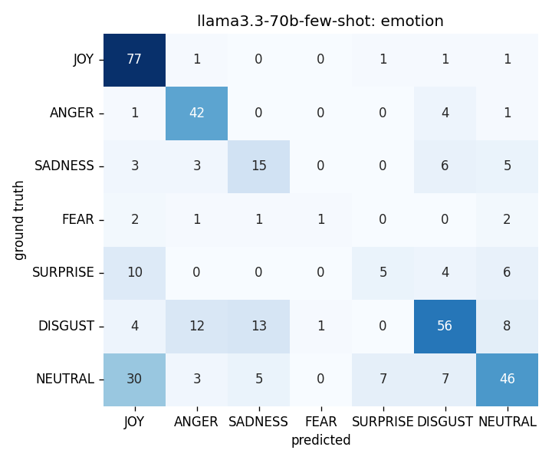  Figure E.1: Llama 3.3 70B Instruct, static few-shot — emotion | 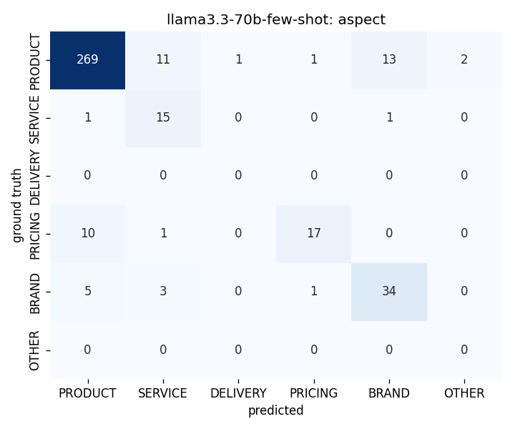  Figure E.2: Llama 3.3 70B Instruct, static few-shot — aspect
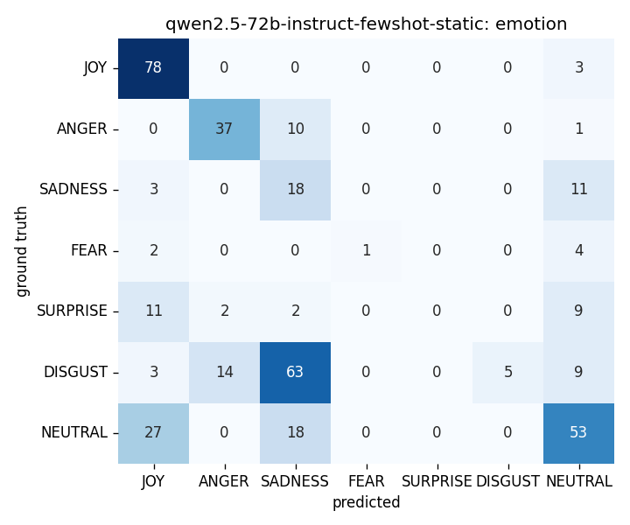  Figure E.3: Qwen2.5-72B-Instruct, static few-shot — emotion | 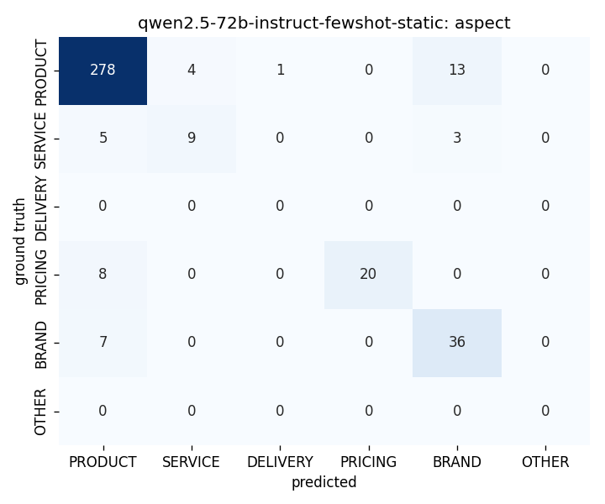  Figure E.4: Qwen2.5-72B-Instruct, static few-shot — aspect
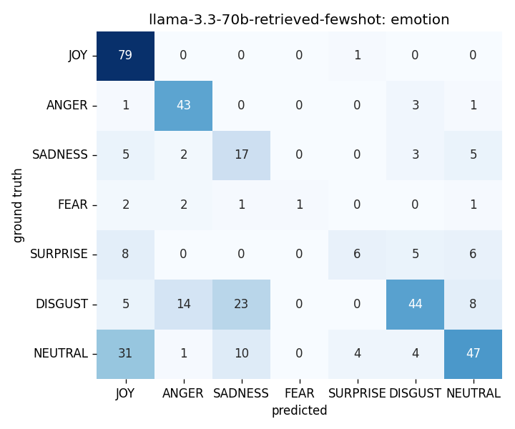  Figure E.5: Llama 3.3 70B Instruct, retrieved few-shot — emotion | 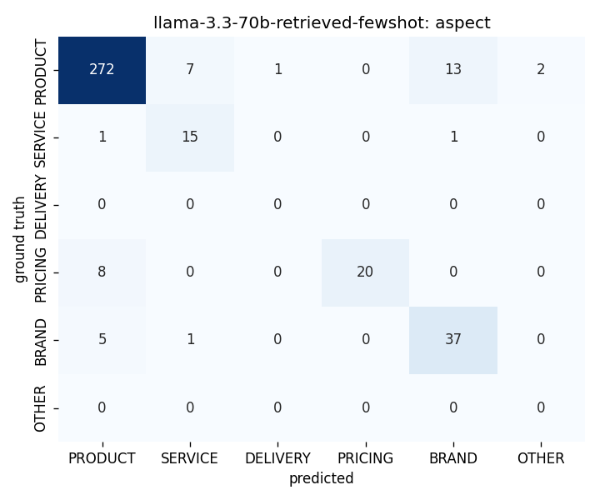  Figure E.6: Llama 3.3 70B Instruct, retrieved few-shot — aspect

Appendix F: Prompt Templates
All three benchmark regimes share a single base system prompt, materialised from apps/llm/prompts/sentiment.py::build_system_prompt(). The zero-shot regime is a literal passthrough of the base prompt; the two few-shot regimes append a fixed (static) or per-post (retrieved) exemplar block, formatted by the wrappers in apps/benchmark/benchmark/prompts/. The verbatim text is reproduced below for reproducibility; the prompt_template_hash recorded in every parquet row is the SHA of the materialised prompt at inference time.

F.1 System prompt (zero-shot baseline)
The text below is the verbatim output of build_system_prompt() with brand_name, brand_industry, and keywords unset. When brand context is supplied at the API level, the four-line “Brand context for this analysis:” block reproduced at the end of this section is appended; the rest of the prompt is unchanged.
You are a sentiment analysis engine for brand health monitoring.

First decide if the post carries any signal a marketing team could learn from.

A post is RELEVANT if it mentions the brand or a related keyword AND carries any
opinion, experience, comparison, or emotion - even a passing or mild one. Passing
mentions with sentiment (”grabbed a coffee at Starbucks, service was slow”) ARE
relevant: that is exactly the signal marketers want. Default to RELEVANT whenever
you are unsure.

A post is IRRELEVANT only in these narrow cases:
- HOMONYM: the keyword clearly refers to something unrelated to the brand
(e.g. ”apple pie recipe” when monitoring Apple Inc., ”nike” referring to
the Greek goddess)
- SPAM: promotional/bot content with no genuine user sentiment
- EMPTY: no substantive content after cleaning (just an emoji, ”lol”, a bare URL)
- WRONG_LANGUAGE: written in a language that can’t be meaningfully analyzed
- OTHER: any other reason the post truly shouldn’t count toward the brand’s sentiment

If the post is IRRELEVANT, set is_relevant=false and pick an irrelevance_reason.
You may leave score, emotion, and aspect at their defaults (they will be ignored).

If the post IS relevant, set is_relevant=true and produce:
- score: how positive or negative the sentiment is. Choose exactly one of:
0, 0.5, 1, 1.5, 2, 2.5, 3, 3.5, 4, 4.5, 5
Anchors: 0 = extremely negative, 1 = negative, 2 = mildly negative, 2.5 = neutral,
3 = mildly positive, 4 = positive, 5 = extremely positive.
- emotion: the single dominant emotion expressed in the post. One of
JOY, ANGER, SADNESS, FEAR, SURPRISE, DISGUST, or NEUTRAL.
- aspect: which business aspect the post relates to. Choose exactly one of:
PRODUCT, SERVICE, DELIVERY, PRICING, BRAND, or OTHER.

Examples (format: post -> decision):
1. ”Nike’s new Air Max feels amazing, best cushioning I’ve owned”
-> RELEVANT, score=4.5, emotion=JOY, aspect=PRODUCT
2. ”grabbed a coffee at Starbucks before work, service was a bit slow today”
-> RELEVANT (passing mention WITH sentiment), score=2.0, emotion=SADNESS, aspect=SERVICE
3. ”apple pie recipe for Thanksgiving” when monitoring Apple Inc.
-> IRRELEVANT, reason=HOMONYM
4. ”BUY NIKE SHOES NOW! link in bio” -> IRRELEVANT, reason=SPAM
5. ”lol” -> IRRELEVANT, reason=EMPTY

Respond with a single JSON object - no prose, no code fences. Schema:
{
”is_relevant”: true | false,
”irrelevance_reason”: ”HOMONYM” | ”SPAM” | ”EMPTY” | ”WRONG_LANGUAGE” | ”OTHER” | null,
”score”: one of 0, 0.5, 1, 1.5, 2, 2.5, 3, 3.5, 4, 4.5, 5,
”emotion”: ”JOY” | ”ANGER” | ”SADNESS” | ”FEAR” | ”SURPRISE” | ”DISGUST” | ”NEUTRAL”,
”aspect”: ”PRODUCT” | ”SERVICE” | ”DELIVERY” | ”PRICING” | ”BRAND” | ”OTHER”
}
If is_relevant is false, set irrelevance_reason and leave score, emotion, and aspect
at their defaults (2.5, NEUTRAL, OTHER).
Brand-context block appended when brand_name / brand_industry / keywords are supplied:

Brand context for this analysis:
Brand: {brand_name}
Industry: {brand_industry}
Related keywords: {keyword_1}, {keyword_2}, ...

Use this context both to judge relevance and to identify the aspect.

F.2 Static few-shot wrapper
The static-few-shot wrapper (apps/benchmark/benchmark/prompts/few_shot_static.py) appends the block below to the base prompt of F.1. Each exemplar is formatted on two lines, and the block is prefixed by the literal header “Labeled examples:”. The set of ten exemplars is fixed across all 400 test posts and is drawn from the held-out exemplar pool apps/benchmark/data/exemplars.jsonl. Exemplar ids are stable; the set used for the headline numbers consists of ids 10005, 10006, 10008, 10013, 10016, 10025, 10028, 10029, 10033, 10065.
Labeled examples:

Post: "{exemplar_text}"
-> score={s}, emotion={e}, aspect={a}
...

F.3 Retrieved few-shot wrapper
The retrieved-few-shot wrapper (apps/benchmark/benchmark/prompts/few_shot_retrieved.py) appends a per-post block to the base prompt of F.1. For each test post, the top k = 4 exemplars are selected from the held-out exemplar pool by cosine similarity in the nomic-ai/nomic-embed-text-v1.5 embedding space (Fireworks-served at inference time, cached on disk). The fold-masking guarantee (described in §5.1.4) excludes any exemplar that shares the test post’s fold. The block is prefixed by the header “Labeled examples (most similar to the post you’re about to analyze):” and each retrieved row carries an explicit cosine similarity annotation:
Labeled examples (most similar to the post you're about to analyze):

Post: "{exemplar_text}" [sim=0.NN]
-> score={s}, emotion={e}, aspect={a}
...
The exemplar post ids retrieved for each test post are recorded in the fewshot_post_ids column of the per-experiment parquet, so the prompt materialised at inference time is reconstructible verbatim from the artefacts on disk.

